**Psychological Effect of Using Virtual Reality in Subject of Islamic Religion in Elementary School**

**Zainal Asril**

Department of Early Childhood Education

Faculty of Education and Teacher Training, Universitas Islam Negeri Imam Bonjol Padang, Indonesia

Jl. Prof. Mahmud Yunus, Anduring, Kota Padang

Email:zainalasril@uinib.ac.id

**Engkizar**

Department of Islamic Religion Faculty of Social, Universitas Negeri Padang, Indonesia

Jl. Prof. Dr. Hamka, Air Tawar, Padang Sumatera Barat

Email:engkizar@fis.unp.ac.id

**Syafrimen Syafril**

Deapartmen of Islamic Early Childhood Education Undergraduate Program,

Faculty of Education and Teacher Training, Universitas Islam Negeri Raden Intan Lampung

Jl. Endro Suratmin, Kota Bandar Lampung, Lampung

Email: syafrimen@radenintan.ac.id

**Zainal Arifin**

Department of Arabic Language Education

Faculty of Education and Teacher Training, Universitas Islam Negeri Imam Bonjol Padang, Indonesia

Jl. Prof. Mahmud Yunus, Anduring, Kota Padang

Email: zainularifin@uinib.ac.id

Received: xx (month), xxxx (year). Accepted: xx (month), xxxx (year). Published: xx (month), xxxx (year)

**ABSTRACT**

The study is aimed at designing and analyzing the psychological effect of using technology-based media, namely Virtual Reality in the subject of Islamic Religion in Elementary School. Research and Development, conducted in six stages, namely; investigation, strategy, improvement, assessment, realization, and estimation (ISI-ARE), is used as the research method. Details of the stages of product development will be explained in part of material and method. The product is validated by two experts in Virtual Reality and animation as well as an educator in the subject of Islamic Religion. There are 60 learners from four elementary schools are involved as participants of the study to see the psychological effects of using virtual reality in their learning process. The data is collected through questionnaires and analyzed by using statistical descriptive of Statistical Package for Social Sciences (SPSS Windows 26.0). The product has been declared feasible and can be used as learning media by the three experts. The findings of the study reveal that there are psychological effects of using virtual reality toward the learners in the learning process, namely; (i) easiness to understand the learning materials, (ii) clarity of the learning material, (iii) interesting and eye-catching display of the learning materials, (iv) enjoyable learning, (v) fun learning, (vi) real-like learning, (vii) willingness to re-use the VR media, (viii) easiness of using the learning media. The eight points are psychologically regarded as appropriate for the development of learners in elementary schools. Moreover, the findings also show that making use of technology-based learning media such as virtual reality can be an alternative for teachers in the Islamic religion classroom in elementary schools.

*Keywords : Psychological effects, virtual reality, concrete learning, ISI-ARE model*

**INTRODUCTION**

The current massive development of technology is undeniably influential in the progress of the education field (Cook et al., 2019; McGovem et al., 2020). The fact is that almost all educational instruments nowadays rely on technology in three processes; planning, learning process, and assessment process (Fabris et al., 2019; Elmqaddem, 2019). Of the three educational processes, the use of technology in the learning process is always interested to be studied and investigated (Liu et al., 2019; Radianti et al., 2020; Marks & Thomas, 2021). Whatever the findings of studies conducted regarding the learning media are always waited by academics; lecturers, teachers, stakeholders, and educators as they will be used as the basic reference for innovation of learning media presented in the classroom (Huang et al.*,* 2019; Ahir et al., 2020; Lee et al., 2022).

The use of media as teaching aids aimed at facilitating the delivery of teaching materials is regarded as an obligation in the classroom. A teacher might not properly deliver his teaching materials only by classically explaining the teaching materials in front of the class without being helped by the teaching media. Prior studies reveal that the use of teaching media in the classroom influences the teaching and learning process Noori et al., (2022), active classroom atmosphere Tak et al., (2022); Greve et al., (2022), joyful learners Serevina et al., (2022), as well as improvement of learners’ learning achievement (Chytas et al., 2022; Sun, 2022; Vilena et al., 2022). On the other hand, teachers who classically deliver the teaching materials such as giving lectures and presentations through PowerPoint in front of the classroom will make the process boring Gnanadurai et al., (2022), passive learners Yang & Goh, (2022) and unsatisfying learning achievement (Hamilton et al., 2021; Lopez et al., 2021). Thus, the use of learning media in the teaching and learning process is inevitable to achieve the learning objectives.

Generally, there must be differences between young learners and adults in terms of the learning process. The process in the elementary level must be fun and enjoyable (Cai, 2021; Oberle et al., (2021) the given learning material must be real and easy to understand (Lin et al., 2021) and avoid abstract materials delivery (Green et al., 2021; Vidergor, 2021). To achieve such an ideal teaching and learning process, teachers must be aware of selecting the teaching method and provide the learning media which is appropriate with the level of the learners that the given teaching materials lead learners to positive psychological effects in learning and the learners gain enjoyable learning experiences. One of the compulsory materials in the subject of Islamic religion in elementary school is performing the pilgrimage of hajj where learners are expected to master the knowledge of hajj and be able to perform the ritual (Hatim, 2018; Syam, 2019). As one of the pillars of Islam, performing hajj has to be taught in schools, yet, the learners are expected not only to master the knowledge related to hajj, but they can have initial skills to perform hajj (Hamka & Saleh, 2020; Shofwanthoni 2019). Referring to previous readings, teaching, and learning related to performing hajj was mostly taught through the classical teaching method; giving a lecture in front of the classroom Afiyah & Usman, (2021), playing the video of hajj and students watch it on screen Chonyta & Rahman, (2021), and directing the learning for practice in a specific location for practicing hajj such as in mosques or nearby hajj dorm. Fig 1 below describes the conventional learning of hajj rituals without any technology-based learning media.

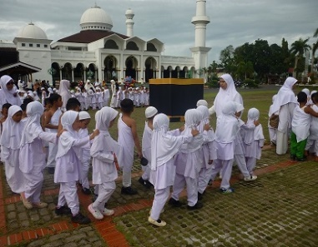 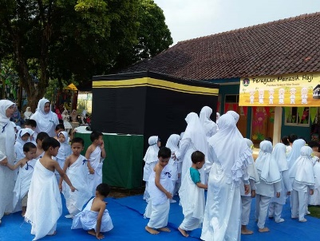 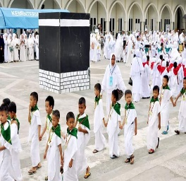

**Fig. 1 Conventional learning of hajj rituals**

The conventional teaching and learning for hajj as shown in the images cannot be performed due to the COVID 19 that the teaching process is mostly conducted through online platforms (Agarwal & Kaushik, 2020; Mulyono et al., 2021). Besides, schools that start conventional meetings limit the number of students who can attend the schools (Hidayat & Wibawa, 2020). Thus, referring to those issues, researchers designed technology-based learning media of Virtual Reality as a teaching aid for teachers that it is easy for them to deliver teaching materials in elementary schools.

By implementing VR on Hajj learning for elementary school, students could experience an insightful and joyful learning process compared to the traditional method. Students can only execute Hajj practice by imagining the real process through the traditional method. However, VR creates a reality-like environment of Hajj rituals through virtual platforms during the learning process for elementary school students (Adi et al., 2021; Yeh et al., 2021). VR-based technology has been widely used by teachers as a learning medium. VR would be a fresh learning method for practicing Hajj specifically for elementary school students. VR is regarded as an advanced technology that connects someone to interact with a loop simulated through a computer or other similar devices (Araiza et al., 2021; Makransky & Petersen 2021). VR can also be simply defined as technology-based media that describes an environment through three dimensions generated by a computer and can interact directly with its users. The virtues of VR make it potential to be learning media such as its ability to present the teaching materials through three dimensions as well as various audiovisual effects that learners experience real-like learning process (Fromm et al., 2021; Syafril et al.,2020).

Previous studies related to the effect of using VR as learning media have been widely conducted; making use of VR in science classrooms Kersting et al., (2021); Parong & Mayer, (2021) VR in Engineering Kumar et al., (2021); Singh et al., (2021); Udeozor et al., (2021), Arts and Animation (Cakiroglu et al., 2021; Gan et al., 2021; Gong et al., 2021; Kim & Lee, 2021). Some studies conclude that making use of VR for learning media affects the classroom atmosphere, active learners’ participation, enjoyable learning, easiness to understand teaching materials, and improvement in learning outcomes. However, making use of VR in Islamic religion classrooms in elementary schools has not really been promoted. Three studies related to using VR in Islamic religion classrooms have been conducted, namely making use of VR in Moral and Characters lesson Widiarti & Firmansyah, (2020), VR in introducing worshiping sites Mustagfirin & Prabowo, (2019), VR in histories of prophets (Abidin & Razak, 2019). The studies reveal that making use of VR in Islamic religion classrooms affects the learning atmosphere, improves learners’ motivation and increases learning outcomes significantly.

Studies related to making use of VR in Islamic religion classrooms have been conducted, yet the number of studies is not significant. Making use of VR related to performing the hajj has not been found. Thus, this study is aimed at designing VR-based learning media which facilitates the learning process during the pandemic. It is assumed that the use of VR in introducing rituals of hajj helps learners to understand the performance accordingly. Moreover, it is believed that VR could bring students to real-like hajj rituals that the abstract concept of hajj could be avoided.

**METHOD**

To design a VR-based learning media related to performing the rituals of hajj, the Research and Development method is implemented through six stages, namely Investigation, Strategy, Improvement, Assessment, Realization, and Estimation (ISI-ARE) (Pahrudin, 2019). Here are the explanation for each stage. ***First***; investigation, this stage begins with collecting information related to the problems faced by teachers and students in learning the rituals of hajj. The information is explored and elaborated directly from four elementary schools in Padang. Besides, interviews were also conducted with the teachers of Islamic religions and learners. In this stage needs analysis is used as the basis of creating the instruments. According to the initial investigation, it was obtained that teachers and learners need technology-based learning media in Islamic religion classrooms especially in introducing rituals of hajj. ***Second***; strategy, in this stage, designing and formulating the VR-based learning media were started. The design is based on the elementary school students' development and needs related to the ritual of hajj. The study was conducted in a team consisting of six professionals from different disciplines, namely an expert in educational psychology, an Islamic educator, an expert in information technology, an animator as well as an expert in pedagogy. After conceptualizing the design, the media was created within three months. ***Third***; improvement, the initial trial for the VR-based learning media was conducted in this phase. The media was first released and used in the classroom consisting of sixty elementary school learners. ***Fourth***; assessment, there are two assessment phases conducted in this stage, namely: (i) the product was assessed by three experts (ii) improving the quality of the product according to the recommendation of the three experts followed by the second assessment after revising the product was done. The product was stated feasible and valid to be used in the classroom by the experts after the second assessment. ***Fifth***; realization, in this stage, the VR-based learning media was initially launched. The product was used in elementary schools. The participants for this initial launch of the learning media were 60 learners. This stage was conducted after the second revision of the product. ***Sixth***; Estimation, this stage is the last one, namely evaluating the product after the final revision. The comments of the learners who become the participants of the studies will be completely elaborated in the findings and discussion parts of this article. A detailed explanation for the six stages in creating VR-based learning media is elaborated in fig 2 below.

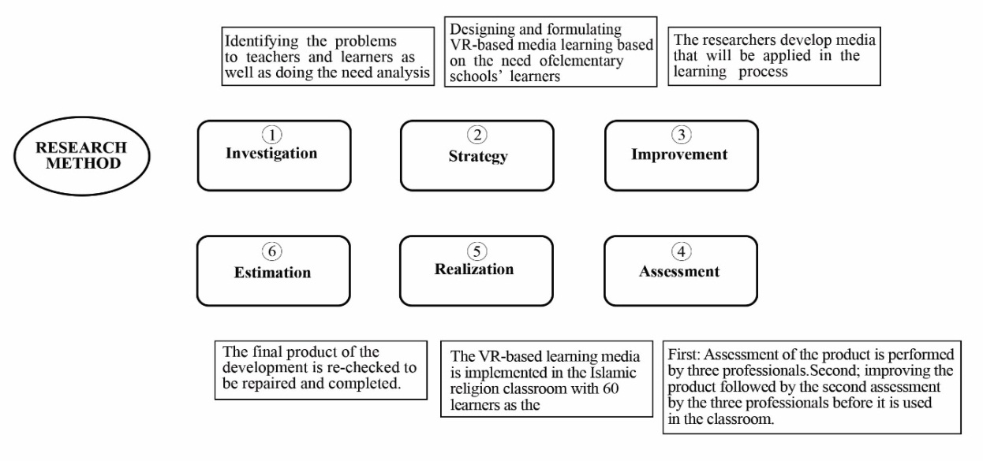

**Fig. 2 Six stages in designing VR-based learning media**

**RESULTS AND DISCUSSION**

This discussion and findings section is divided into two parts. The first part will elaborate on all features and content of the VR-based learning media. The VR is used to facilitate learners to understand the rituals of hajj. The second part will be about learners' responses related to their psychological effects after experiencing learning by using VR as learning media.

**3.1. Making Use of VR-based learning media in Subject of Islamic Religion in Elementary Schools**

Although making use of VR as a learning medium in the education field is no anymore alien, VR as a learning medium in Islamic religious classrooms is not popular. Many religion teachers may not be familiar with the learning media, particularly when the media is used to exhibit rituals of hajj. Thus, VR might be regarded as the latest learning media in this context. There are five steps conducted when the learning media is used to activate the application that the media can properly function. The following paragraphs will be related to the five steps accompanied by pictures for a better explanation.

First, learners put the VR glasses on their faces properly. The glasses will function to direct the user's head and eye movement so that they could concentrate in the displayed virtual world. With the help of these glasses, learners feel as if they are actually in the place and state of the material being studied. The glasses also function to help learners see all the features and materials in the application. Second, after the learners put the glasses on their faces, there is an "ON" button that all the activities will turn on. All control devices have been labeled based on their functions so that learners easily operate the devices. These two steps can be seen in fig 3 below:

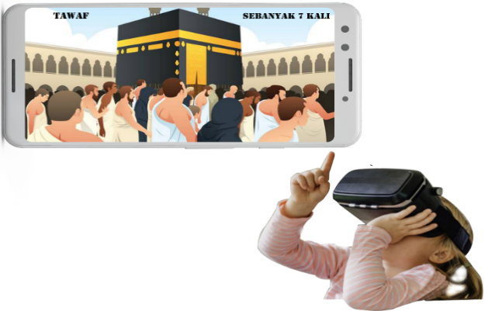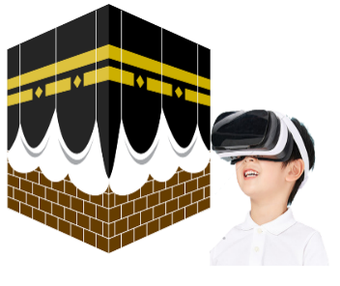

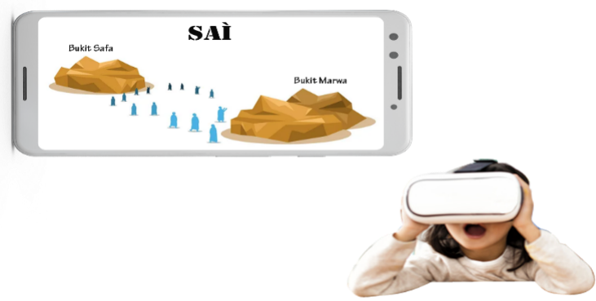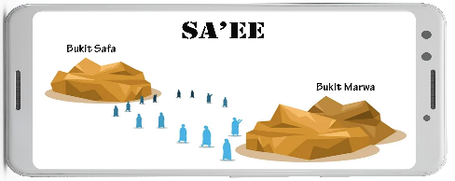

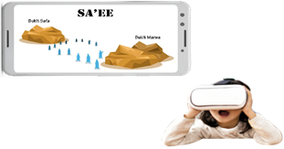

**Fig. 3 Plot of making use of VR as a learning medium**

Third, learners could select the available learning materials based on the features in the VR application. The material is initially started by introducing the concept of hajj and the procedures of the rituals in form of short narration; i.e. the concept of hajj, terms, and conditions of hajj, obligation and sunnah in hajj, prohibitions in hajj, and other related information about the Islamic pilgrimage as it is shown in the fig 4 below:

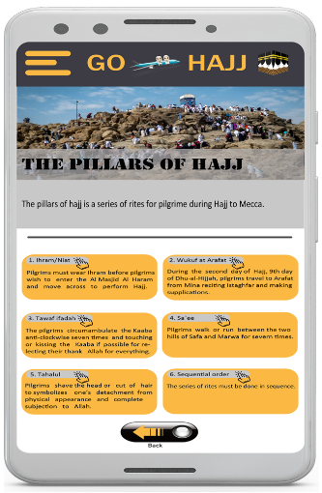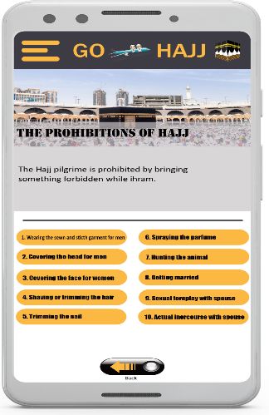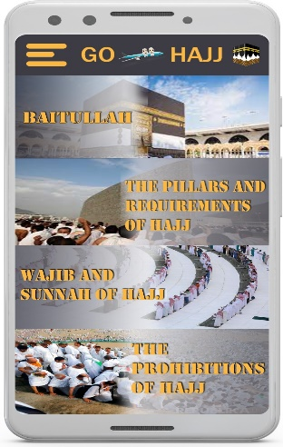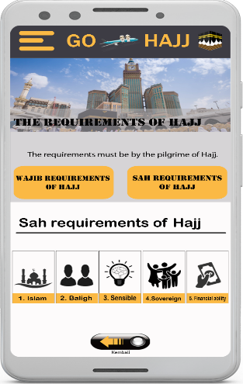

**Fig. 4 Short Material Narration in the VR feature**

Fourth, after the learners are exposed to the features and the procedures of hajj, learners are directed to virtually visit some sites which are compulsory to attend during the rituals; such as visiting and wuquf in Kaaba, spending one night in Arafah, Sai in Safa and Marwa hills and other sites. All the sites are completely presented in the VR features. To move from one to another sites, learners are simply require to nod their head and move their eyes to certain directions that the VR glasses will properly function. Three dimension pictures are presented to the learners as well as some verses must be recited in every site during the rituals. The visited sites are in accordance with real hajj rituals as can be seen in fig 5 below.

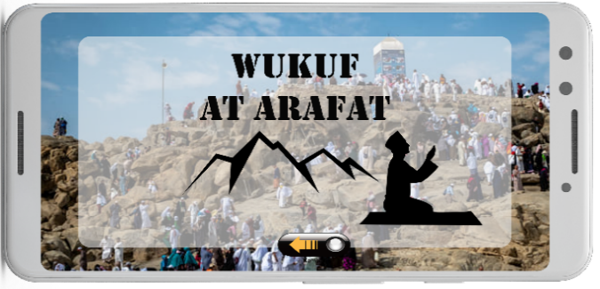

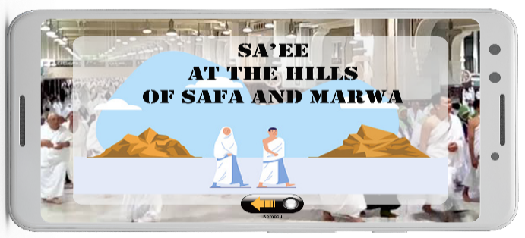

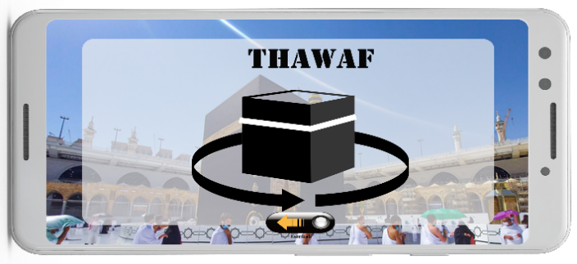

**Fig. 5 Features of Sites of Hajj in the VR application**

Fifth, to end the ritual activities, the learners can simply press the “off” button which is available on the right side of the glasses.

**3.2. Psychological Effects of Using VR-based Learning Media for Islamic Religion classroom in Elementary Schools**

As it is previously elaborated, the researcher created the VR-based learning media and used it in the classroom to find out the psychological effect of the devices on learners in elementary school. Thus, the participants of this study are 60 students from four different elementary schools. All the participants are four-grade students. Data were collected by using the questionnaire about the psychological effects of using VR-based learning media. The questionnaire consists of eight items and five alternative answers, namely extremely disagree, disagree, less agree, agree, and extremely agree. All the obtained data were analyzed by using descriptive statistics of Statistical Package for Social Sciences (SPSS Windows 26.0). The findings of the analysis are described in the following table 1.

**Table 1. The Psychological Effect of Making Use the VR-based learning media**

|  |  |  |  |  |  |  |  |
| --- | --- | --- | --- | --- | --- | --- | --- |
| No. | Psychological Effects of Using the V-based Learning Media | N = 60 respondents | | | | | |
| Frequency and Percentage | | | | | |
| Extremely disagree | Disagree | Less Agree | Agree | Extremely agree | Total |
| 1. | Easy to understand the materials |  |  | 6  10% | 3  5% | 51  85% | 60  100% |
| 2. | The material is clearly displayed |  | 3  5% | 4  6,66% | 23  38,4% | 30  50% | 60  100% |
| 3. | The materials are interestingly presented |  | 4  6,66% | 8  13,3% | 30  50% | 18  30% | 60  100% |
| 4. | Learning process is fun and enjoyable |  |  | 6  10,0% | 6  10,0% | 48  80,0% | 60  100% |
| 5. | Learning process is not boring |  |  |  | 10  16,7% | 50  83,3% | 60  100% |
| 6. | Experiencing real-like performance of hajj rituals. |  |  | 1  1,7% | 12  20% | 47  78,3% | 60  100% |
| 7. | Wishing to learn by using VR based learning media |  |  |  | 6  10,0% | 54  90,0% | 60  100% |
| 8. | The learning media is easy to be used |  |  | 6  10,0% | 6  10,0% | 48  80,0% | 60  100% |

The results of the analysis in table 1 above reveal that learners generally gave a high response (Agree to Strongly Agree) on the entire statement given to them. Although there were also responses (Disagree, and Disagree) on some of the statements given, the percentage of responses to these statements is very low. A high percentage of overall statements in this study indicate respondents' agreement on the psychological effects of using VR-based learning media in the learning process. In other words, students gave a positive response and felt the psychological effects of using VR-based learning media developed in this study.

The use of technology as a learning medium is the best choice that teachers can make in the era of digital learning (Chen & Hsu, 2020; Reeves et al., 2021). However, in the context of Islamic religious education, of course, not all materials can be delivered based on technology help, for example, the monotheism (tauhid) concept which is more abstract (Husna et al., 2020). However, learning that requires a concrete motor movement process such as prayer, ablution (wudhu'), tayammum material certainly requires good and appropriate media, so that students easily understand the material, enjoy learning, are active, and can increase motivation and interest in learning.

The Ritual of Hajj is one of the compulsory materials learned by elementary school students. Thus, it will be difficult for learners to understand the abstract concept and material delivery if it is delivered through the classical teaching method. The two prominent instruments which are interrelated in Islamic religion classrooms are the availability of the media and teachers. Teachers are expected to have the capability and competency to operate the advanced technology-based learning media that they can integrate the ICT in their teaching and learning process (Engkizar et al., 2018; Syafril et al., 2021). Issues related to Islamic religion teachers' low competency in mastering the advanced technology is no anymore new Payvar, (2018), they tend to teach the material through classical delivery; lecture (Hanafi et al., 2021; Engkizar et al., 2021). Lack of training related to the advanced technology use in the classroom Karakostantaki & Stavrianos, (2021), lack of interest to improve their skills in the ICT field Fahmi et al (2021), cause the low quality of teaching and learning process, boring classroom atmosphere, and dull learning process (Idris et al., 2019).

This research has succeeded in designing learning media based on VR technology in Islamic religious learning. As previously explained, the material for the implementation of the rituals of hajj is always taught classically, but the presence of learning media based on VR technology has provided learning media innovations that can be another alternative for teachers as a medium for learning Islam. The use of VR technology in learning the procedures for carrying out Hajj can provide new experiences and give a positive impression to students. VR technology-based media aims to visualize abstract material to be seen in real terms, in fact, such learning is suitable for use in elementary school students. In the context of psychology, learning at this age should be concrete and abstract learning should be avoided (Lei et al., 2018; Yaremych & Persky, 2019).

Finally, the findings reveal that making use of VR-based learning media has positive psychological effects on learners. It shows that most learners strongly agree that the material is delivered using learning media based on VR technology, and seems to give a positive impression on the psychological atmosphere of students in learning. The impression is felt by the ease with which students understand the material because it is displayed clearly and attractively. Participants do not get bored quickly and learning becomes more enjoyable. Besides that, students were also impressed that VR technology-based learning media had brought them as if they were in a real atmosphere, even overall students agreed and wanted to re-use VR-based learning media because it is not difficult to operate. This is indeed in line with various expert views and research findings which state that learning situations are influenced by various factors including competent teachers Blomeke et al., (2020), students' motivation and interest in learning Somer & Llinares, (2021), selection of appropriate methods Zendler & Greiner, (2020) and availability of media that can facilitate learning (Naik et al., 2020). If all these instruments are available, it can be ensured that the learning process and results are achieved properly in accordance with the objectives.

**CONCLUSION**

It is revealed that the VR-based learning media designed in this study scientifically contributes to giving psychological effect to students in the teaching and learning process. It indicates that making use of the VR-based learning media can be an alternative for teachers to facilitate the teaching and learning process; especially in the pandemic current situation in which the media can be used for remote or daring classrooms. As the rapid growth of technology, as well as the use of technology, promotes psychological effects toward the individual, innovation in the educational field should continuously occur in line with the rapid development of the technology itself. Teachers as mediators, motivators, and agents of change should be the main actors to adapt to the rapid growth that they could give the best contribution toward the educational world.

**BIBLIOGRAPHY**

Abidin, M. I. Z., & Razak, A. A. (2019, February). Modelling of the Prophet mosque in virtual reality. *In Proceedings of the 2019 8th International Conference on Software and Computer Applications* (pp. 320-324).

Adi Badiozaman, I. F., Segar, A. R., & Hii, J. (2021). A pilot evaluation of technology–enabled active learning through a Hybrid Augmented and Virtual Reality app. *Innovations in Education and Teaching International*, 1-11.

Afiyah, N., & Usman, J. (2021). Implementasi Pengembangan Nilai Agama Dan Moral Anak Kelompok B Melalui Kegiatan Manasik Haji. *JP2KG AUD (Jurnal Pendidikan, Pengasuhan, Kesehatan dan Gizi Anak Usia Dini)*, 2(2), 83-96.

Agarwal, S., & Kaushik, J. S. (2020). Student’s perception of online learning during COVID pandemic. *The Indian Journal of Pediatrics,* 87(7), 554-554.

Ahir, K., Govani, K., Gajera, R., & Shah, M. (2020). Application on virtual reality for enhanced education learning, military training and sports. *Augmented Human Research,* 5(1), 1-9.

Araiza-Alba, P., Keane, T., Chen, W. S., & Kaufman, J. (2021). Immersive virtual reality as a tool to learn problem-solving skills. *Computers & Education*, 164, 104121.

Blomeke, S., Kaiser, G., König, J., & Jentsch, A. (2020). Profiles of mathematics teachers’ competence and their relation to instructional quality. *ZDM*, 52(2), 329-342.

Cai, P. (2021). Thinking skills development in mobile learning: The case of elementary school students studying environmental studies. *Thinking Skills and Creativity*, 42, 100922.

Çakıroğlu, Ü., Aydın, M., Özkan, A., Turan, Ş., & Cihan, A. (2021). Perceived learning in virtual reality and animation-based learning environments: A case of the understanding our body topic. *Education and Information Technologies*, 26(5), 5109-5126.

Chen, Y. L., & Hsu, C. C. (2020). Self-regulated mobile game-based English learning in a virtual reality environment. *Computers & Education*, 154, 103910.

Chonyta, D., & Rahman, T. (2021). Metode Bimbingan Manasik Haji Di Kbihu Nurul Haramain. *Haramain: Jurnal Manajemen Bisnis,* 1(3), 167-176.

Chytas, D., Salmas, M., Skandalakis, G. P., & Troupis, T. G. (2022). Augmented and virtual reality in anatomy education: Can they be effective if they do not provide immersive experience?. *Anatomical Sciences Education*, 15(2), 431-433.

Cook, M., Lischer-Katz, Z., Hall, N., Hardesty, J., Johnson, J., McDonald, R., & Carlisle, T. (2019). Challenges and strategies for educational virtual reality. *Information Technology and Libraries*, 38(4), 25-48.

Elmqaddem, N. (2019). Augmented reality and virtual reality in education. Myth or reality?. *International journal of emerging technologies in learning*, 14(3).

Engkizar, E., Muliati, I., Rahman, R., & Alfurqan, A. (2018). The Importance of Integrating ICT into Islamic Study Teaching and Learning Process. *Khalifa: Journal of Islamic Education*, 1(2), 148-168.

Engkizar, E., Munawir, K., Kaputra, S., Arifin, Z., Syafril, S., Anwar, F., & Mutathahirin, M. (2021). Building of Family-based Islamic Character for Children in Tablighi Jamaat Community. *Ta'dib*, 24(2), 299-310.

Fahmi, A. N., Yusuf, M., & Muchtarom, M. (2021). Integration of Technology in Learning Activities: E-Module on Islamic Religious Education Learning for Vocational High School Students. *Journal of Education Technology*, 5(2), 282-290.

Fromm, J., Radianti, J., Wehking, C., Stieglitz, S., Majchrzak, T. A., & vom Brocke, J. (2021). More than experience?-On the unique opportunities of virtual reality to afford a holistic experiential learning cycle. *The Internet and higher education*, 50, 100804.

Gan, B., Zhang, C., Chen, Y., & Chen, Y. C. (2021). Research on role modeling and behavior control of virtual reality animation interactive system in Internet of Things. *Journal of Real-Time Image Processing*, 18(4), 1069-1083.

Gnanadurai, J. B., Thirumurugan, S., & Vinothina, V. (2022). Exploring Immersive Technology in Education for Smart Cities. In Immersive Technology in Smart Cities (pp. 1-25). *Springer, Cham.*

Gong, Y. (2021). Application of virtual reality teaching method and artificial intelligence technology in digital media art creation. *Ecological Informatics*, 63, 101304.

Green, A. L., Ferrante, S., Boaz, T. L., Kutash, K., & Wheeldon-Reece, B. (2021). Evaluation of the SPARK child mentoring program: A social and emotional learning curriculum for elementary school students. *The Journal of Primary Prevention*, 42(5), 531-547.

Greve, S., Thumel, M., Jastrow, F., Krieger, C., Schwedler, A., & Süßenbach, J. (2022). The use of digital media in primary school PE–student perspectives on product-oriented ways of lesson staging. *Physical Education and Sport Pedagogy*, 27(1), 43-58.

Hamilton, D., McKechnie, J., Edgerton, E., & Wilson, C. (2021). Immersive virtual reality as a pedagogical tool in education: a systematic literature review of quantitative learning outcomes and experimental design. *Journal of Computers in Education*, 8(1), 1-32.

Hamka, H., & Saleh, M. (2021). Application of Contextual Teaching and Learning Models in Improving the Manasic Understanding of Haji for X-Class Students. *Al-Iftah: Journal of Islamic studies and society*, 2(1), 13-29.

Hanafi, Y., Taufiq, A., Saefi, M., Ikhsan, M. A., Diyana, T. N., Thoriquttyas, T., & Anam, F. K. (2021). The new identity of Indonesian Islamic boarding schools in the “new normal”: the education leadership response to COVID-19. *Heliyon*, 7(3), e06549.

Hidayat, D. A. S. R. U. N., Anisti, P., & Wibawa, D. (2020). Crisis management and communication experience in education during the covid–19 pandemic in indonesia. *Jurnal Komunikasi: Malaysian Journal of Communication*, 36(3), 67-82.

Huang, K. T., Ball, C., Francis, J., Ratan, R., Boumis, J., & Fordham, J. (2019). Augmented versus virtual reality in education: an exploratory study examining science knowledge retention when using augmented reality/virtual reality mobile applications. *Cyberpsychology, Behavior, and Social Networking*, 22(2), 105-110.

Husna, S. A., Ritonga, M., Lahmi, A., Saputra, R., & Ayu, S. (2020). The teachers unpreparedness in carrying out islamic education learning using the revised 2013 curriculum in elementary school. *European Journal of Molecular & Clinical Medicine*, 7(2), 1520-1528.

Idris, N. R. A. B., Sirat, M., & Wan, C. D. (2019). Toward Sustainable Islamic Communities in Malaysia: The Role of Islamic-Based Higher Education Institutions (IHEIs). In Higher Education and Belief Systems in the Asia Pacific Region (pp. 27-40). *Springer, Singapore.*

Karakostantaki, E., & Stavrianos, K. (2021). The use of ICT in teaching religious education in primary school. *Education and Information Technologies*, 26(3), 3231-3250.

Kersting, M., Steier, R., & Venville, G. (2021). Exploring participant engagement during an astrophysics virtual reality experience at a science festival. *International Journal of Science Education*, Part B, 11(1), 17-34.

Kim, Y., & Lee, H. (2022). Falling in love with virtual reality art: a new perspective on 3D immersive virtual reality for future sustaining art consumption. *International Journal of Human–Computer Interaction*, 38(4), 371-382.

Kumar, V. V., Carberry, D., Beenfeldt, C., Andersson, M. P., Mansouri, S. S., & Gallucci, F. (2021). Virtual reality in chemical and biochemical engineering education and training. *Education for Chemical Engineers*, 36, 143-153.

Lee, S. W. Y., Hsu, Y. T., & Cheng, K. H. (2022). Do curious students learn more science in an immersive virtual reality environment? Exploring the impact of advance organizers and epistemic curiosity. *Computers & Education*, 182, 104456.

Lei, X., Zhang, A., Wang, B., & Rau, P. L. P. (2018, July). Can virtual reality help children learn mathematics better? The application of vr headset in children’s discipline education. In International Conference on Cross-Cultural Design (pp. 60-69). *Springer, Cham.*

Lin, C. P., Yang, S. J., Lin, K. Y., Looi, C. K., & Chen, Y. H. (2022). Explorations of two approaches to learning CT in a game environment for elementary school students. *Journal of Computers in Education*, 9(2), 261-290.

Liu, Q., Cheng, Z., & Chen, M. (2019). Effects of environmental education on environmental ethics and literacy based on virtual reality technology. *The Electronic Library*, 37(5), 860-877.

Lopez, M., Arriaga, J. G. C., Álvarez, J. P. N., González, R. T., Elizondo-Leal, J. A., Valdez-García, J. E., & Carrión, B. (2021). Virtual reality vs traditional education: Is there any advantage in human neuroanatomy teaching?. *Computers & Electrical Engineering*, 93, 107282.

M. Hatim, “Kurikulum pendidikan agama Islam di sekolah umum,” *El-Hikmah J. Kaji. dan Penelit. Pendidik. Islam*., vol. 12, no. 2, pp. 140–163, 2018.

Makransky, G., & Petersen, G. B. (2021). The cognitive affective model of immersive learning (CAMIL): A theoretical research-based model of learning in immersive virtual reality. *Educational Psychology Review*, 33(3), 937-958.

Marks, B., & Thomas, J. (2022). Adoption of virtual reality technology in higher education: An evaluation of five teaching semesters in a purpose-designed laboratory. *Education and information technologies*, 27(1), 1287-1305.

McGovern, E., Moreira, G., & Luna-Nevarez, C. (2020). An application of virtual reality in education: Can this technology enhance the quality of students’ learning experience?. *Journal of education for business*, 95(7), 490-496.

Mulyono, H., Suryoputro, G., & Jamil, S. R. (2021). The application of WhatsApp to support online learning during the COVID-19 pandemic in Indonesia. *Heliyon*, 7(8), e07853.

Mustagfirin, M., Haryadi, T., & Prabowo, D. P. (2019, December). Adaptasi Media Digital Dalam Revitalisasi Artefak Museum Masjid Agung Demak Di Era 4.0. *In Seminar Nasional Science and Engineering National Seminar* (Vol. 1, No. 1).

Mutambik, I., Lee, J., & Almuqrin, A. (2020). Role of gender and social context in readiness for e-learning in Saudi high schools. *Distance Education*, 41(4), 515-539.

Naik, G., Chitre, C., Bhalla, M., & Rajan, J. (2020). Impact of use of technology on student learning outcomes: Evidence from a large-scale experiment in India. *World Development*, 127, 104736.

Noori, A. Q., Orfan, S. N., Akramy, S. A., & Hashemi, A. (2022). The use of social media in EFL learning and teaching in higher education of Afghanistan. *Cogent Social Sciences*, 8(1), 2027613.

Oberle, E., Zeni, M., Munday, F., & Brussoni, M. (2021). Support factors and barriers for outdoor learning in elementary schools: A systemic perspective. *American Journal of Health Education*, 52(5), 251-265.

Pahrudin, M. P. (2019). Development of islamic value-based picture in biology learning with the ISI-ARE model. *Tadris: Jurnal Keguruan dan Ilmu Tarbiyah*, 4(2), 237-248.

Parong, J., & Mayer, R. E. (2021). Cognitive and affective processes for learning science in immersive virtual reality. *Journal of Computer Assisted Learning*, 37(1), 226-241.

Radianti, J., Majchrzak, T. A., Fromm, J., & Wohlgenannt, I. (2020). A systematic review of immersive virtual reality applications for higher education: Design elements, lessons learned, and research agenda. *Computers & Education*, 147, 103778.

Reeves, S. M., Crippen, K. J., & McCray, E. D. (2021). The varied experience of undergraduate students learning chemistry in virtual reality laboratories. *Computers & Education*, 175, 104320.

Serevina, V., Koul, R., Morales, M. P., & Nugroho, D. A. (2022). Influence of Website-Based E-Learning in the Pandemic Era: Improving Students' Creative Thinking Skills through Educational Management. *International Journal on E-Learning*, 21(1), 39-60.

Shofwanthoni, M. A., Ridlo, S., & Elmubarok, Z. (2019). The development of authentic assessment instrument of Hajj Manasik practices of IX grade of SMP PGRI 10 Candi in Sidoarjo Regency. *Journal of Research and Educational Research Evaluation*, 8(1), 14-21.

Singh, G., Mantri, A., Sharma, O., & Kaur, R. (2021). Virtual reality learning environment for enhancing electronics engineering laboratory experience. *Computer Applications in Engineering Education*, 29(1), 229-243.

Somers, T., & Llinares, A. (2021). Students’ motivation for content and language integrated learning and the role of programme intensity. *International Journal of Bilingual Education and Bilingualism*, 24(6), 839-854.

Sun, Y. (2022). Research About the Influence of Digital Social Media on Learning Ability Based on “Segmentation-Outsourcing-Integration” Method. In Proceedings of the 11th International Conference on Computer Engineering and Networks (pp. 920-926). *Springer, Singapore.*

Syafril, S., Asril, Z., Engkizar, E., Zafirah, A., Agusti, F. A., & Sugiharta, I. (2021, February). Designing prototype model of virtual geometry in mathematics learning using augmented reality. *In Journal of Physics: Conference Series* (Vol. 1796, No. 1, p. 012035). IOP Publishing.

Syafril, S., Latifah, S., Engkizar, E., Damri, D., Asril, Z., & Yaumas, N. E. (2021, February). Hybrid learning on problem-solving abiities in physics learning: A literature review. *In Journal of Physics: Conference Series* (Vol. 1796, No. 1, p. 012021). IOP Publishing.

Syam, A. R. (2019). Guru dan Pengembangan Kurikulum Pendidikan Agama Islam di Era Revolusi Industri 4.0. *TADRIS: Jurnal Pendidikan Islam*, 14(1), 1-18.

Tak, N. Y., Lim, H. J., Lim, D. S., Hwang, Y. S., & Jung, I. H. (2022). Effect of self‐learning media based on 360° virtual reality for learning periodontal instrument skills. *European Journal of Dental Education.*

Udeozor, C., Toyoda, R., Russo Abegão, F., & Glassey, J. (2021). Perceptions of the use of virtual reality games for chemical engineering education and professional training. *Higher Education Pedagogies*, 6(1), 175-194.

Vergara, D., Antón-Sancho, Á., Extremera, J., & Fernández-Arias, P. (2021). *Assessment of virtual reality as a didactic resource in higher education. Sustainability*, 13(22), 12730.

Vidergor, H. E. (2021). Effects of digital escape room on gameful experience, collaboration, and motivation of elementary school students. *Computers & Education*, 166, 104156.

Villena-Taranilla, R., Tirado-Olivares, S., Cózar-Gutiérrez, R., & González-Calero, J. A. (2022). Effects of virtual reality on learning outcomes in K-6 education: A meta-analysis. *Educational Research Review*, 100434.

Widiarta, I. M., & Firmansyah, M. W. (2020). Pengembangan Game Edukasi Pembelajaran Akhlak Berbasis Virtual Reality. *Jurnal Informatika Teknologi dan Sains*, 2(3), 173-181.

Yang, F., & Goh, Y. M. (2022). VR and MR technology for safety management education: An authentic learning approach. *Safety science*, 148, 105645.

Yaremych, H. E., & Persky, S. (2019). Tracing physical behavior in virtual reality: a narrative review of applications to social psychology. *Journal of Experimental Social Psychology*, 85, 103845.

Yeh, H. C., Tseng, S. S., & Heng, L. (2021). Enhancing EFL students’ intracultural learning through virtual reality. *Interactive Learning Environments*, 1-10.

Zendler, A., & Greiner, H. (2020). The effect of two instructional methods on learning outcome in chemistry education: The experiment method and computer simulation. *Education for Chemical Engineers*, 30, 9-19.