**Developing Soft Skills new learning method and Student Counseling Guidance Based-Islamic Education Teaching: A Bibliometrics reviews**

**Elihami**

Universitas Muhammadiyah Enrekang, Indonesia

Email: elihamid72@gmail.com

**Mohd. Melbourne**

Universitas philiphiness, Filipina

Received: xx (month), xxxx (year). Accepted: xx (month), xxxx (year). Published: xx (month), xxxx (year)

**ABSTRACT**

This research explained the phases of the systematic process of learning method. This study aims to examine the innovation of the role of religious teachers in the Counselling Guidance of Elementary School Students through bibliometric studies from 2021-2022. VOS viewer application analyses bibliographic reviews drawn from the most productive authors, journals, keywords, and citation references. And then, the relative growth rate and time needed to double have been calculated from 2021-2022. The study results indicate that the role of innovation as an Islamic religious education teacher is responsible for counselling activities for elementary school students. The innovation component has an important role that can be achieved when implemented collaboratively in implementing the role of a religious teacher and counsellor, as for the novelty and contribution of the research, namely the study conducted in the innovation of the role of Islamic religious education teachers in conducting student counselling guidance in elementary schools. This research contributes to showing the development and urgency of the learning method. Meanwhile, the limitation is that the articles reviewed were only sourced from Scopus. Therefore, this study suggests that future studies require a comparative analysis approach by implementing the Web of Science.

Keywords: Education, teachers, teaching, learning

***ABSTRAK***

*Penelitian ini menjelaskan tahapan-tahapan proses sistematis Metode Pembelajaran. Penelitian ini bertujuan untuk mengkaji inovasi peran guru agama dalam Bimbingan Konseling Siswa Sekolah Dasar melalui studi bibliometrik dari tahun 2021-2022. Aplikasi menggunakan Vosviewer menganalisis ulasan bibliografi yang diambil dari penulis, jurnal, kata kunci, dan referensi kutipan yang paling produktif. Kemudian, tingkat pertumbuhan relatif dan waktu yang dibutuhkan untuk menggandakan telah dihitung dari 2021-2022. Hasil penelitian menunjukkan bahwa peran inovasi sebagai guru pendidikan agama Islam bertanggung jawab atas kegiatan konseling bagi siswa sekolah dasar. Komponen inovasi memiliki peran penting yang dapat dicapai apabila diimplementasikan secara kolaboratif dalam melaksanakan peran guru agama dan konselor, adapun kebaruan dan kontribusi penelitian yaitu kajian yang dilakukan dalam inovasi peran guru pendidikan agama Islam. dalam melakukan bimbingan konseling siswa di sekolah dasar. Penelitian ini memberikan kontribusi untuk menunjukkan perkembangan dan urgensi metode pembelajaran. Sedangkan batasannya adalah artikel yang direview hanya bersumber dari Scopus. Oleh karena itu, penelitian ini menyarankan agar penelitian selanjutnya memerlukan pendekatan analisis komparatif dengan mengimplementasikan database Web of Science (WoS) dan menambah durasi periode pencarian artikel terbaru khususnya metode pembelajaran.*

*Kata Kunci: Pendidikan, guru, pengajaran, pembelajaran*

**INTRODUCTION**

In the world of the COVID-19 Pandemic, it has forced the shift from a teaching model to online learning at the university level globally. The creative teaching process is critical in the Covid-19 era, so a conceptual analysis process, interactive dialogue, and reflection are needed in conducting the online learning process (Kadiyono et al., 2020). Therefore, online teaching quality is the key to student's academic success, especially in the Covid-19 era, and students' entire motivation is needed (Supriadi et al. 2020). With the existence of a learning environment method, the impact is directly or indirectly influenced by great educators. Learning method for studying objective and visual class models in order to achieve excellent classification results in achieving the goals to be achieved (Agarwal and Roth 2002); (Agarwal and Roth 2002); (Rowley, Baluja, and Kanade 1998); (Fergus, Perona, and Zisserman 2003); (Lowe 1999); (Vaillant, Monrocq, and Cun 1994); (Viola and Jones 2001); (Osuna, Freund, and Girosi 1997); (Weber, Welling, and Perona 2000).

Elementary school students are those aged around 6 to 12 years who are undergoing the stage of childhood development and will enter early adolescence (Brookover et al., 1978). Many factors, approaches, theories, and models have been used to investigate school climate, resulting in a complex body of knowledge. The stage of development of elementary school-aged children is a period where they are preparing themselves for the continuation of their future development (Anderson, 1982). In their developmental tasks, they often encounter obstacles and problems, so they depend significantly on other people, especially parents and teachers (Mashuri & Suyatno, 2018). Therefore, elementary school-age children need special attention from parents and teachers. Children or students are individuals who grow and develop towards maturity (Tumiran et al., 2020). Along with increasing age, children or students experience a continuous learning process from previously not knowing to know; from previously unexperienced to experiencing the experience of his life directly. In learning and understanding something, a teacher who can accompany children or students is needed (Syamsuri et al., 2020).

This is where the innovation of the role of Islamic Religion teachers in conducting counseling guidance is at the same time to make Islam the primary source in shaping the personality of a good Muslim, especially for elementary school students (Ansharuddin, 2018). Based on the Al-Quran and As-Sunnah, Islam directs and guides humans to the path that pleases Him by forming a personality with good morals (Baiquni, 1995). As the Messenger of Allah (SAW) said: "Indeed, I was sent to the perfect noble character (Muchsin et al., 2018). God sent the Prophet to guide and direct humans towards true goodness and as a counselor figure capable of solving various problems related to the human soul so that humans avoid all negative traits (Lukens-Bull, 2001). Therefore, humans are expected to give each other guidance following their capacity and provide Counseling to remain patient and trusting in facing the real journey of life.

A teacher not only conveys knowledge to his students but also assists them in achieving educational success. In carrying out each activity in teaching and learning, the teacher's task is to guide his students (Maulana, 2017). However, students also need unique guidance, especially when dealing with personality-related problems, to be able to solve the problems correctly (Paut, 2016). This is where the fundamental role of the existence of guidance and Counseling in schools. Guidance and Counseling, as a component of education, have a significant role in fulfilling the rights of students to obtain educational services following their talents, interests, and abilities (Lagudador & Dotong, 2014). Counselors who can develop students' talents, interests, and abilities are facilitated/provided by the central government or local governments according to the needs of the education unit (Banks & Banks, 1989).

Learning is the process of storing information and knowledge in your memory so that it can be used in the future to do a specific action successfully or to understand something precisely. Learning is the process of gaining valuable knowledge and information that may be used to improve one's awareness and intelligence (Duggan 1996). If you want to learn to be effective and efficient, it must be helpful, practical, intentional, cumulative, and completed at appropriate stages (Viola & Jones, 2001) (Holmes et al., 2020).

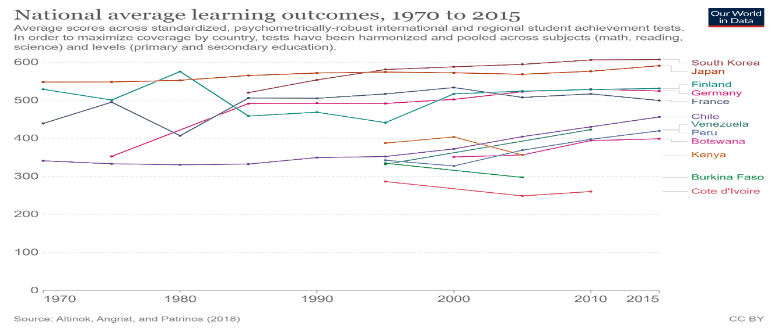

Figure 1. Learning outcomes

Figure 1 shows the learning outcomes from 1970 to 2015. There are numerous advantages to studying (Annand 2011). However, learning needs dedication. Learning more about yourself and the world around you will necessitate a commitment to learning and a pledge to continue learning and seeking out additional information (Alavi and Taghizadeh 2013). Learning encourages more learning, knowledge encourages more knowledge, and skills encourage more skills (Kumar et al. 2011). Learning encompasses everything you are now and will become in the future. Learning improves your thoughts, ideas, solutions, comprehension, skills, and awareness, to name a few benefits (Garrison, Anderson, and Garrison 2003). Everything on this page will provide you with the foundation upon which you can build. Everything seems conceivable from there (Arbaugh and Rau 2007).

The literature used is from the Scopus database from 2012 to 2022, a trend in learning methods. The study was used through bibliometrics. Meanwhile, researchers use bibliometrics as an essential thing to map bibliographic information on specific topics. Therefore, this article aims to complement other essential components of teacher and learning method study maps to achieve a more thorough mapping from 2012 to 2022. This study focuses on bibliometrics concerning publication trends, the most influential journals, citation patterns, author keywords, creator collaborations, collaborative institutions, and country statistics of the published authors (Rourke et al. 2007). As a result, the research is characterized by the following formulation of the problem. There are questions as follows what is the trend of publicationof learning methods in 2012-2022? Which journals published the most learning method in 2012-2022? What is the citation pattern of the learning method in 2012-2022? What are the author keyword trends of learning methods 2012-2022?

**METHOD**

This research employs a bibliographic design of studies using systematic and explicit mapping methods. This research used a qualitative case study to approach the research to understand how they Explore teachers and emotions, especially in memos. The case study is an object to be studied, not a methodological option, and the researcher can use various research tools to research that object. In this study, the instrument used a semi-structured interview to collect data about the learning method (Arbaugh, Bangert, and Cleveland-Innes 2010). Furthermore, four stages of bibliographical studies are used in the research, which includes search processes, bibliographic filters, a comprehensive bibliography, and content analysis.

**Figure 2.** Article review process

Several articles that have strong links and attachments were obtained by researchers based on the following procedure: First, to identify the articles. Article identification is intended to sort and select various articles so that the articles used are only the ones related to the topics discussed. This is done by inputting the keywords "learning method" in the search column with restrictions from 2012 to 2022. Researchers obtained 999 articles with indications related to the topic based on the search process. The second stage is verifying the various articles found so that they lead to needed articles and have a close correlation in compiling studies related to the learning method. After conducting the verification, 242 articles/journals were obtained that were considered relevant and truly conical with the study theme of the learning method. This article is an article that the researcher will use as a reference in studying related " learning methods "(Akyol and Garrison 2008).

In this study, the researcher used a qualitative research method. A semi-structured interview is done to gather information. The researcher gathers the participants in a WhatsApp group and provides them specific guidelines (Akyol, Garrison, and Ozden 2009). They must comprehend the material to the point where they are familiar with the depth and breadth of the interview, and they must continue to review the original audio recordings for authenticity. Because transcription would be time-consuming, irritating, and tedious, this is the only practical approach to begin familiarizing yourself with the data. To explain the trend, the researcher clustered the data into themes after analysis (Akyol and Garrison 2008). This step reduces some of the ineffective data to focus on the data relevant to the theme (Akyol, Garrison, and Ozden 2009). This step reduces some of the ineffective data to focus on the data relevant to the theme. Keep an eye out for clusters or groupings of items utilized together throughout the data translation and analysis methods. The researcher must refocus on the investigation at a higher level of themes (Arbaugh and Benbunan-Finch 2006). Instead of focusing on codes, a higher level of themes will sort the various codes into prospective themes and place all essential coded data extracts below the scope of discovered themes (Diaz et al. 2010).

The primary purpose of education is to figure out how to offer the learning method research outcome foundationally. (1). To look into the authorship patterns in education literacy; (2). To find out how much collaboration there is in research production and publication distribution; (3). In the realm of digital literacy, to determine the proportionate growth rate and time required for doubling; (4). Determine the distribution of publications and research publications by the document. (5). To look into the education literacy keywords.

**RESULTS AND DISCUSSION**

The current research is limited to items found in the Google Scholar collection. The study's keyword is "education literacy and equality": A bibliometric examination of the output of publications from 2012 to 2022. This study has five processes to complete: word key determination, data search, article selection, data validation, and data analysis. The keywords are chosen following the study's objectives, which include education literacy and equality. Because the database collects and updates data daily, it is essential to avoid daily update bias. The data is read and examined once the results of searching data in foreign journals are picked and approved. Both selection and validation are made using diagrams and data tables that are divided into several categories, including the number of publications per year, types of publications, core journals, most productive researchers, number of publications based on affiliation, country, and the distribution of themes that are the focus of the study on education literacy and equality. The category is then evaluated in terms of the article's importance. The result of Bibliometrics' of the term of the phases of the systematic process in the learning method. The trend of publication in 2012-2022 about the phases of the systematic process is as follows.

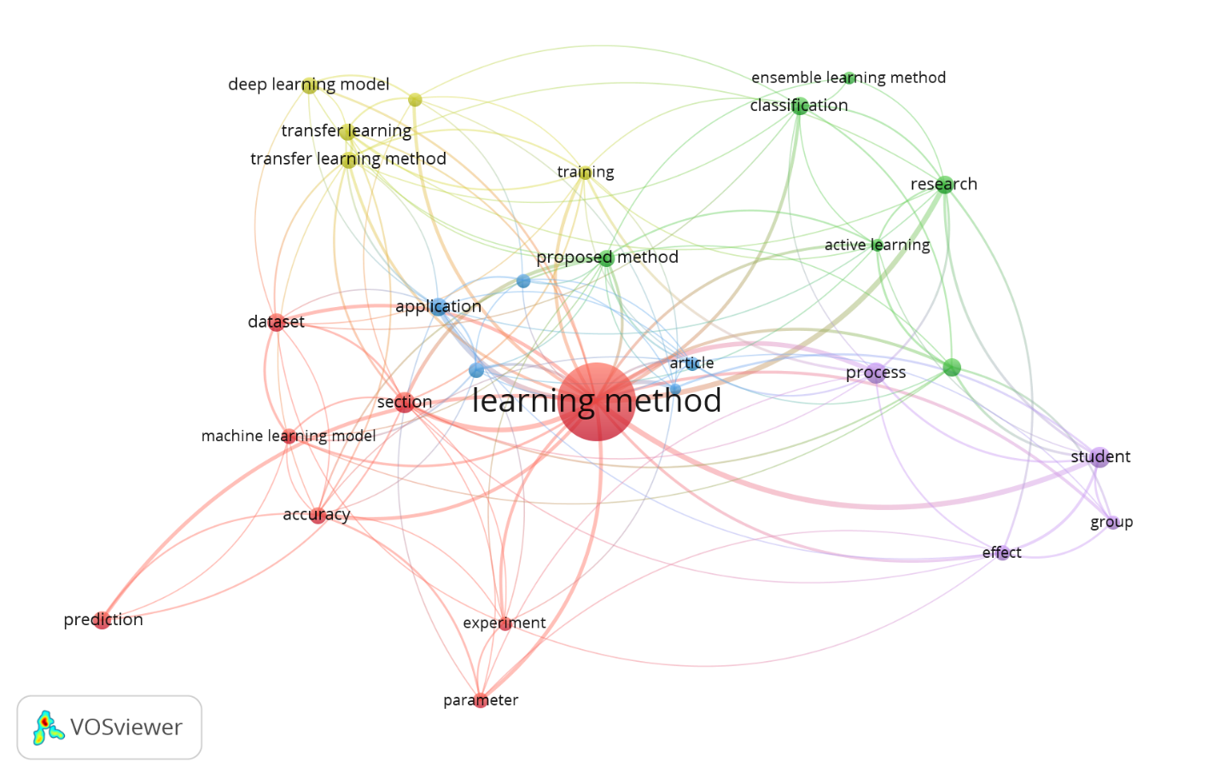

Figure 3. Network Visualization: Cluster of discussion topics on learning method

Referring to the results of the identification detailed in Figure 3 above, it can be described how the themes that have been grouped will then be sorted for review with those that have a correlation based on the themes discussed. The following is a table that maps concepts or themes based on clusters related to the study of the learning method.

**Table 1.** Themes grouped based on clusters

|  |  |  |
| --- | --- | --- |
| **Cluster** | **Concepts** | **Total** |
| Cluster 1 | Accuracy, dataset, experiment, learning method, machine learning model, parameter, prediction, section | 8 |
| Cluster 2 | Active learning, active learning method, classification, ensemble learning method, research | 6 |
| Cluster 3 | Application, article, effectiveness, new method, reinforcement learning | 5 |
| Cluster 4 | Advantage, deep learning model, training, transfer learning, transfer learning method, | 5 |
| Cluster 5 | The effect, group, process, student | 4 |

Figure 3. The hazing publishes or perishes the phases of the systematic process in the learning method.

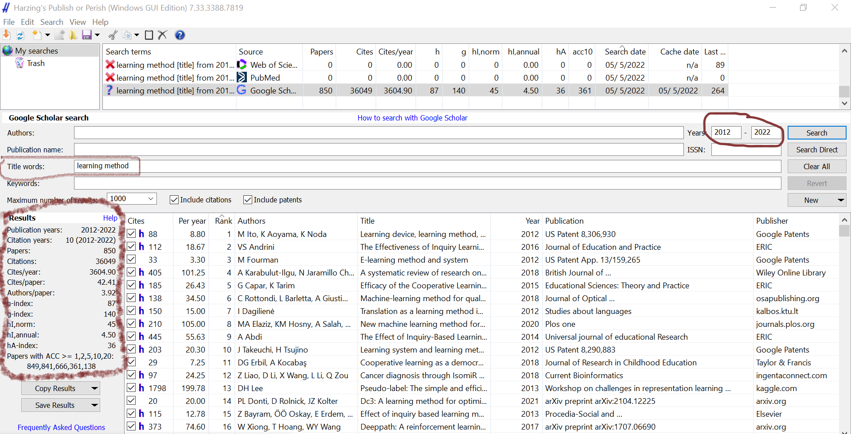

According to Figure 4, The actual search results generated 999 bibliographies, filtered into 242 chosen bibliographies using the publish or perish tool. Seven hundred fifty-seven bibliographies were not chosen because they did not match the set criteria. Table 1 shows the total number of bibliographies generated by the publishing or perishes application for each year. Citation 38375, h-index 88, g-index 141, and hA index 36, hI, norm;46.. The most publication occurred in 2022- 2022 about the phases of the systematic process of the learning method.

Table 2. The Most Widely Published Journal Article of the term "the term of the phases of the systematic process in the learning method.

|  |  |  |  |
| --- | --- | --- | --- |
| No. | Journal Name | Number of Articles | Link |
| 1 | Psychology and Education Journal | 15 | psychologyandeducation.net |
| 2 | Journal of Ethics and Society | 2 | ijethics.com |
| 3 | European Journal of Molecular & Clinical Medicine | 3 | https://www.ejmcm.com/ |
| 4 | Anatolian Journal of Education | 1 | https://e-aje.net/index.php?lang=en |
| 5 | Journal of Applied Issues in Islamic Education | 1 | http://qaiie.ir |
| 6 | Dinasti International Journal of Education Management And Social Science | 1 | [https://dinastipub.org](https://dinastipub.org/DIJEMSS/article/view/344) |
| 7 | Islamic Life Journal | 3 | [http://mail.islamiclifej.com](http://mail.islamiclifej.com/article-1-489-en.html) |
| 8 | Universal Journal of Educational Research | 9 | http://www.hrpub.org |
| 9 | Journal for Multicultural Education | 1 | <https://www.emerald>  grouppublishing.com |
| 10 | Journal of Islamic Studies | 4 | http://journal.  iainbukittinggi.ac.id |
| 11 | Journal of Education and Scientific Studies | 1 | [https://www.iasj.net/iasj](https://www.iasj.net/iasj/download/679c25a9d3130447) |
| 12 | International Journal of Ethics and Society | 1 | https://ijethics.com. |
| 13 | Journal of Indonesian Student Assessment and Evaluation | 1 | http://journal.unj.ac.id |
| 14 | Journal of Islamic Accounting and Business Research | 1 | https://www.emerald.com. |
| 15 | Journal of Physics: Conference Series | 8 | https://iopscience.iop.org |
| 16 | Journal of Arak University of Medical Sciences | 1 | http://jams.arakmu.ac.ir |
| 17 | Journal of Strategic Management Studies | 1 | http://www.smsjournal.ir |
| 18 | The International Journal of Language and Cultural (TIJOLAC) | 1 | <https://www.growingscholar.or> |
| 19 | IEEE: Journal of Islamic Education at Elementary School | 1 | <http://jiees>.  alkhoziny.ac.id |
| 20 | Aesthetic surgery journal | 1 | <https://academic>.  .com |
| 21 | International Journal of Islamic Economics and Finance Studies | 1 | https://dergipark.org |
| 22 | VITARA International Journal of Civilizational Studies and Human Sciences | 1 | [https://bitarajournal.com](https://bitarajournal.com/) |
| 23 | International Journal of Multicultural and Multireligious Understanding | 1 | <https://ijmmu.com> |
| 24 | Universal journal of educational Research | 3 | <https://www.hrpub.org/> |
| 24 | Systematic Reviews in Pharmacy | 1 | [https://www. rm](https://www.sysrevpharm)  sysrevpha.org |
| 25 | Applied Soft Computing | 6 | <https://journals.elsevier.com/applied-soft-computing>. |
| 26 | Journal of Social Sciences | 1 | <https://thescipub.com/jss> |

Table 2 above shows that some journals listed in number 1 published numbers of papers (15 papers) in the Psychology and Education Journal. Then, each journal listed in number 2 was published (9 papers) by the *Universal Journal of Educational Research*.

*Citation Amount-based Analysis (Citations Rates per Year)*

Figure 2 depicts the citation numbers of articles in the flipped classroom. The citation pattern showed from 2012 to 2022 as follows:

Figure 4. Citation amount-based analysis

*Top Ten Most Cited Articles*

Figure 4 shows the most frequently cited teaching and teacher education papers from 2012 to 2022. J Allen, L Rowan, P Singh's publications, which were published in 2020, received the most citations in the first series, with 115, followed by J Allen, L Rowan, P Singh, who received 315. Because they were greater than 200 and less than 300, the third and fourth sequences each earned significant citations. Meanwhile, the citations in the fifth through tenth places were similarly sufficient, more significant than 170 and fewer than 220.

Table 3. The Top Most Cited Articles of the term of the phases of the systematic process of ‘*learning method”* in the year 2012-2022.

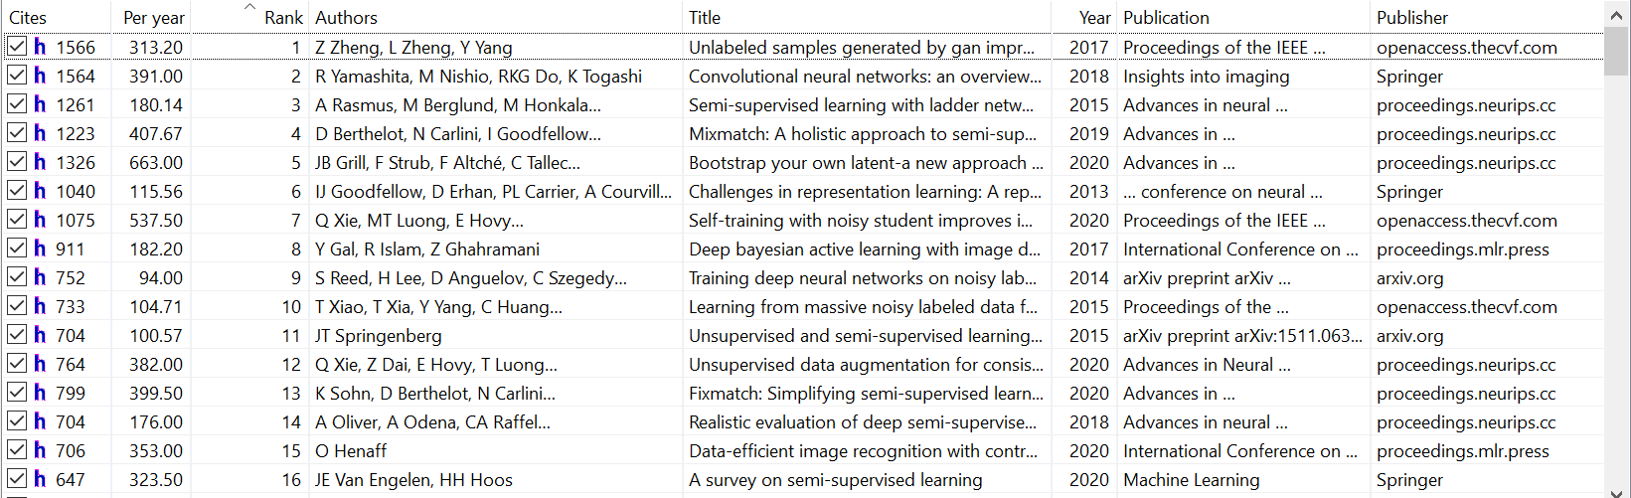

Table 3 shows that Zheng published two papers with significant impact in 2017 as Top citations (1566).

*Author Keyword-based Analysis*

The author keyword analysis was performed using the VOS viewer program for the phases of the systematic process in establishing a successful Learning Method”. The 325 author keywords were grouped into 12 clusters, each with a distinct hue. Cluster 1 (red) consists of 27 items, cluster 2 (green) consists of 15 items, cluster 3 (blue) consists of 12 items, cluster 4 (yellow) consists of 16 items, cluster 5 (purple) consists of 19 items, cluster 6 (aqua) consists of 18 items, cluster 7 (orange) consists of 14 items, cluster 9 (brown) consists of 19 items, cluster 9 (pink) consists of 13 items, cluster 13 (salmon) consists of 15 items, cluster 11 (lime) consists of 15 item, and cluster 10 (gray) consists of 8 items.

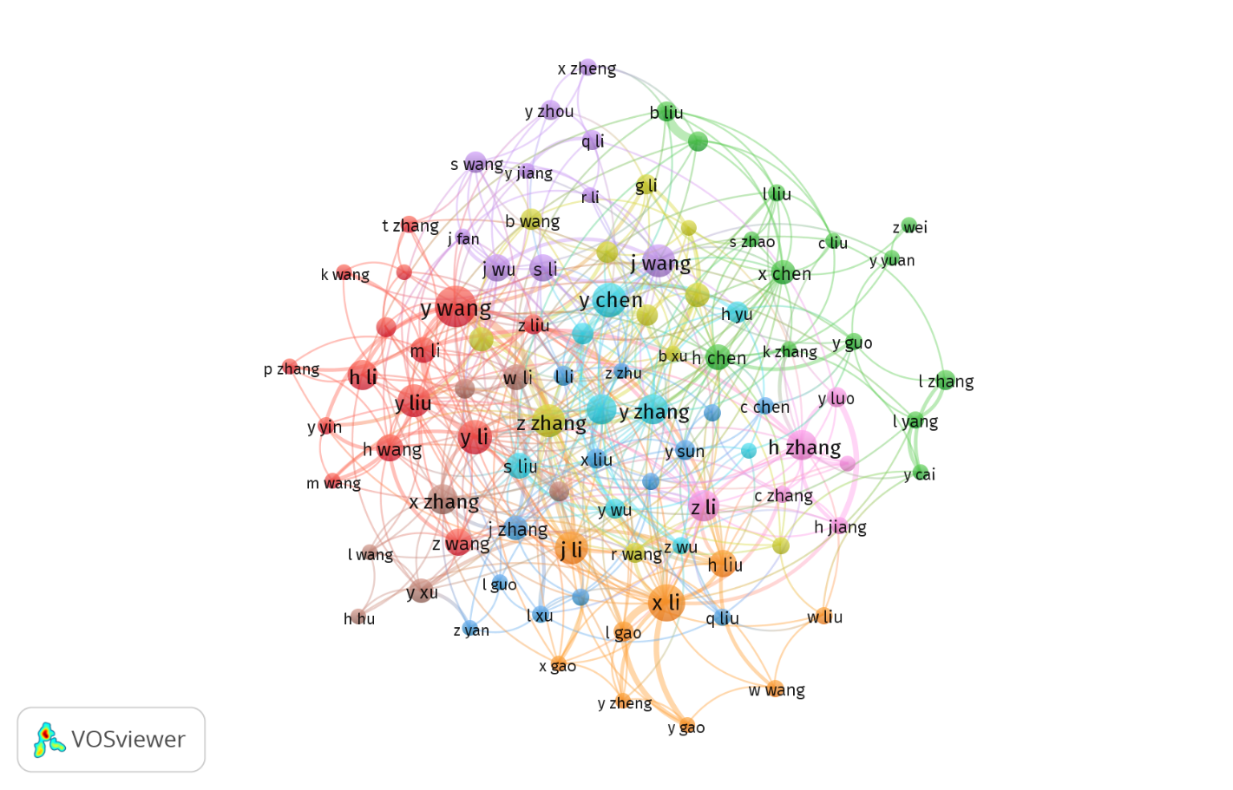

Figure 5. *Author Keyword-based Analysis*

*Author Collaboration-based Analysis*

The findings of an author cooperation study utilizing VOSViewer with the number of instances of at least one document from 998 writers yielded six significantly related authors. Each contributor was given five links and one document. Author cooperation was organized into one cluster (red) of five entries. Figure 5 depicts the author's collaboration pattern. Reference date: 2022-05-05 15:51:01 -0700, Publication years: 2012-2022,Citation years: 10 (2012-2022), Papers: 998, Citations: 38375, Citations/year: 3837.50 (acc1=996, acc2=977, acc5=717, acc10=368, acc20=138), Citations/paper: 38.45, **Authors/paper:** 3.90/4.0/4 (mean/median/mode), Age-weighted citation rate: 11472.01 (sqrt=107.11), 3624.75/author, Hirsch h-index: 87 (a=5.07, m=8.70, 15937 cites=41.5% coverage), Egghe g-index: 141 (g/h=1.62, 20054 cites=52.3% coverage), PoP hI,norm: 46, PoP hI,annual: 4.60, Fassin hA-index:36.

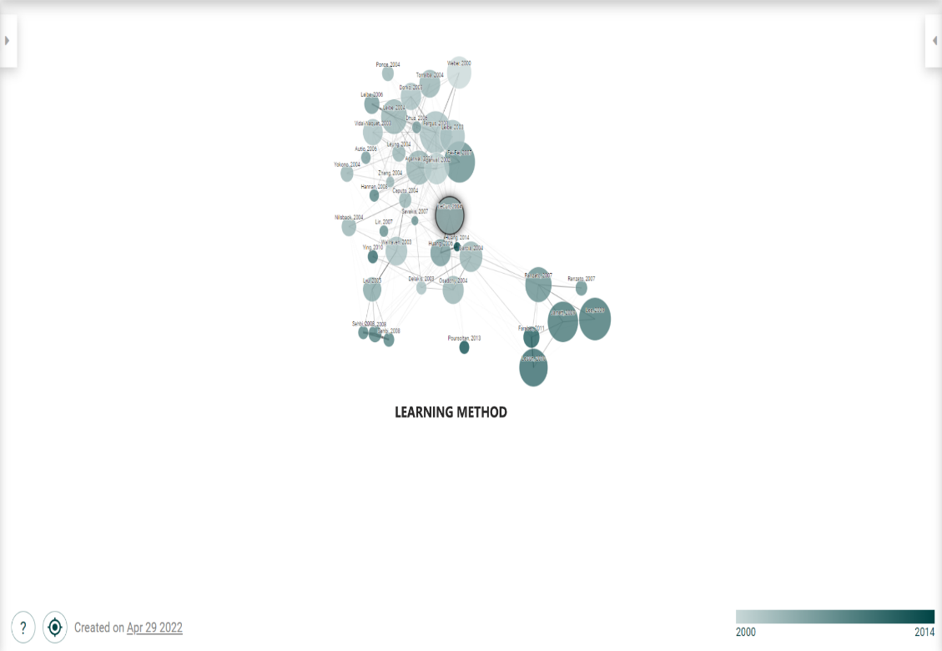

Figure 6. *Authors (Connected papers)*

Figure 5 shows that connected papers about learning method as we know that the program consists of two main components by learning method: a pedagogy prototype with clearly defined principles to drive classroom and study skills and a set of materials to encourage instructors to engage in reflective thought and debate as they enhance their classroom and study abilities. The components of the program are outlined in full below. It is worth noting that research is being conducted in parallel with the campaign to see how effective the model is. Early evaluations indicate that it has the potential to improve both pedagogy and student outcomes. Learning outcomes and perceptions/evaluations of the learning environment are both affected by the quality of the learning environment. Perceptions/evaluations of the learning environment and study approach, as well as the relationship between study approach and learning outcome quality Deep, approaches to learning are more likely to produce higher quality learning than those that do not.

An aspect of external education's arid religious and ethical ideals is the construction of an integrated Islamic-based primary school curriculum fused with public schools (Syakir, 2020). Therefore, the results of the innovation of the teacher's role in student counseling guidance in elementary schools are changes in character values. Researchers implemented the steps of innovation in the role of religious teachers in elementary schools with the stages (1) Making a list of student bills for worship activities (Elihami, 2020b) and (2) Making a rote schedule (Syarif et al., 2021) (3) Motivating students through stories and shows inspiring stories and good stories, (4) Make a notebook about the activities that have been done every day which consists of commendable and uncommendable actions (Elihami, 2020a). The design aims to assess students' character in terms of honesty, responsibility, discipline, independence, and obedient worship (Assidiq et al., 2020). This is in line with the research results showing that habituation innovation is very effective in increasing the fundamental values of Islamic education. Students form good cultures such as throwing garbage in its place, waiting in line, praying in congregation, reciting the Koran, memorizing daily prayers and short letters, and their morals improve (Syaparuddin & Elihami, 2020).

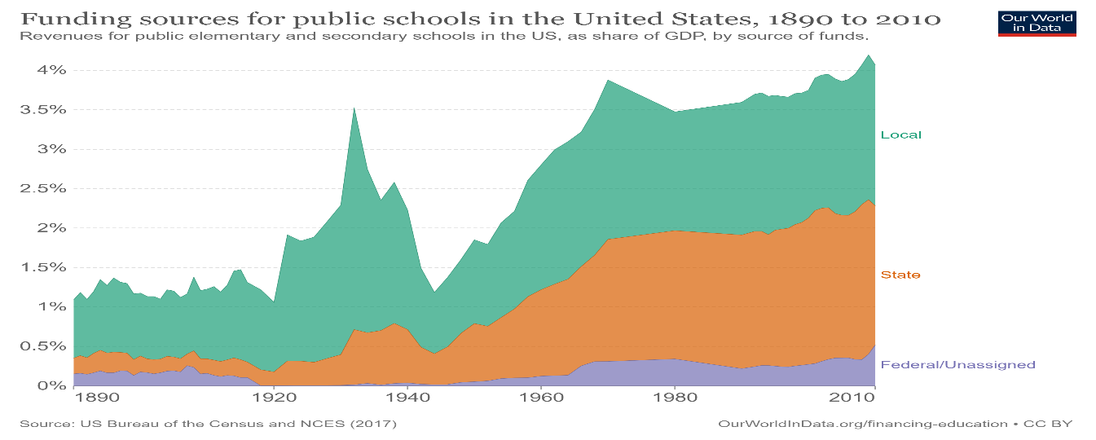

Figure 7. [Funding sources for public schools in the United States, 1890 to 2010](https://ourworldindata.org/grapher/revenues-for-public-schools-by-source-gdp-us)

Figure 1 shows that in most countries, primary education is now seen as a right and a responsibility: governments are often expected to guarantee access to primary education, and citizens are often forced by law to obtain some level of education (Tomei, 2010). This was not always the case in the mid-nineteenth century. Most industrialized countries today began to improve primary education mainly through public funding and government participation (Bosman & Zagenczyk, 2011). Data from this period suggest that government finances for educational growth come from various sources, but municipal taxes play an essential role (Tomei, 2003). The historical significance of the city's support for public schools is crucial in helping us.

The result of publishing or perishing “counseling guidance” in 2010-2021 is as follows.

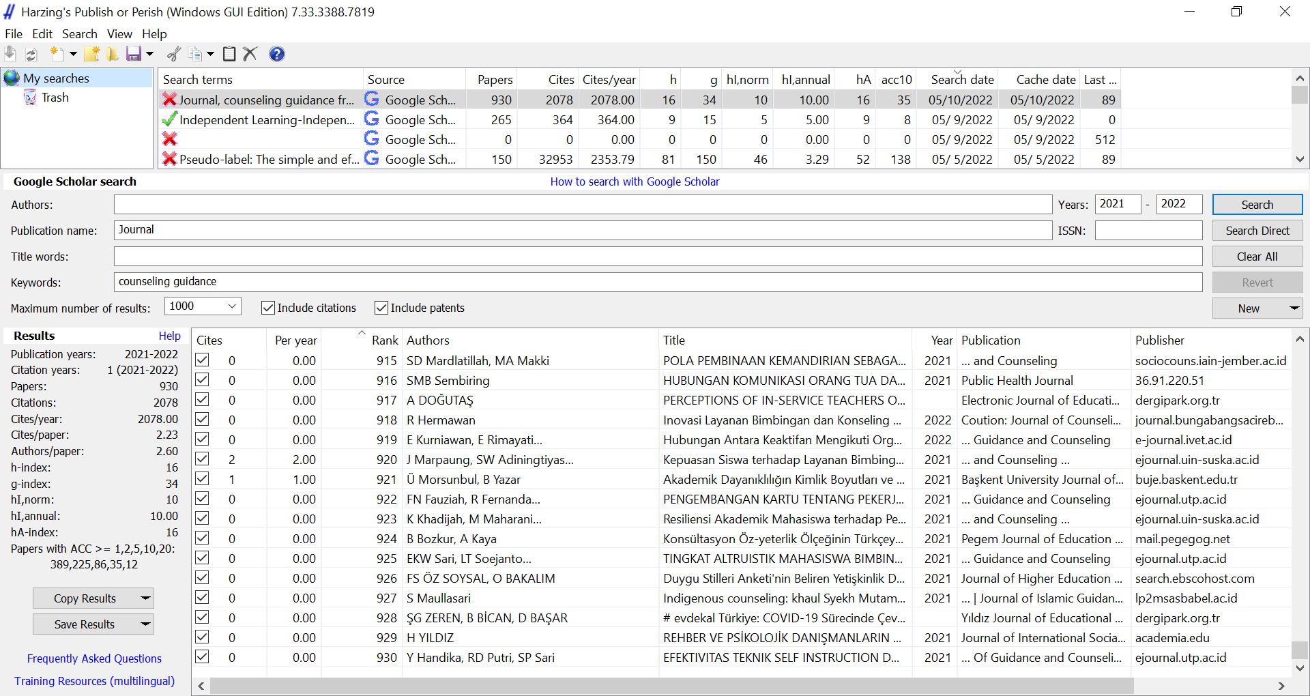

Figure 8. Publish or perish (windows GUI edition) about “counseling guidance” in 2010-2021

The preliminary search results using the Publish or perish (windows GUI edition) Journal, counseling guidance from 2021 to 2022 claim resulted in the term counseling guidance” appendices, sorted into four terms designated appendices into publication name as journal and Google Scholar database. There were four keywords (counseling guidance is 420 papers. And then, the figure 1 showed that Reference date: 2022-05-10 16:00:38 -0700, Publication years: 2021-2022, Citation years: 1 (2021-2022), Papers: 930, Citations: 2078, Citations/year: 2078.00 (acc1=389, acc2=225, acc5=86, acc10=35, acc20=12) ,Citations/paper: 2.23, Authors/paper: 2.60/3.0/3 (mean/median/mode), Age-weighted citation rate: 2077.00 (sqrt=45.57), 1028.12/author, Hirsch h-index: 16 (a=8.12, m=16.00, 961 cites=46.2% coverage), Egghe g-index: 34 (g/h=2.13, 1190 cites=57.3% coverage), PoP hI,norm: 10, PoP hI,annual: 10.00 and Fassin hA-index: 16.

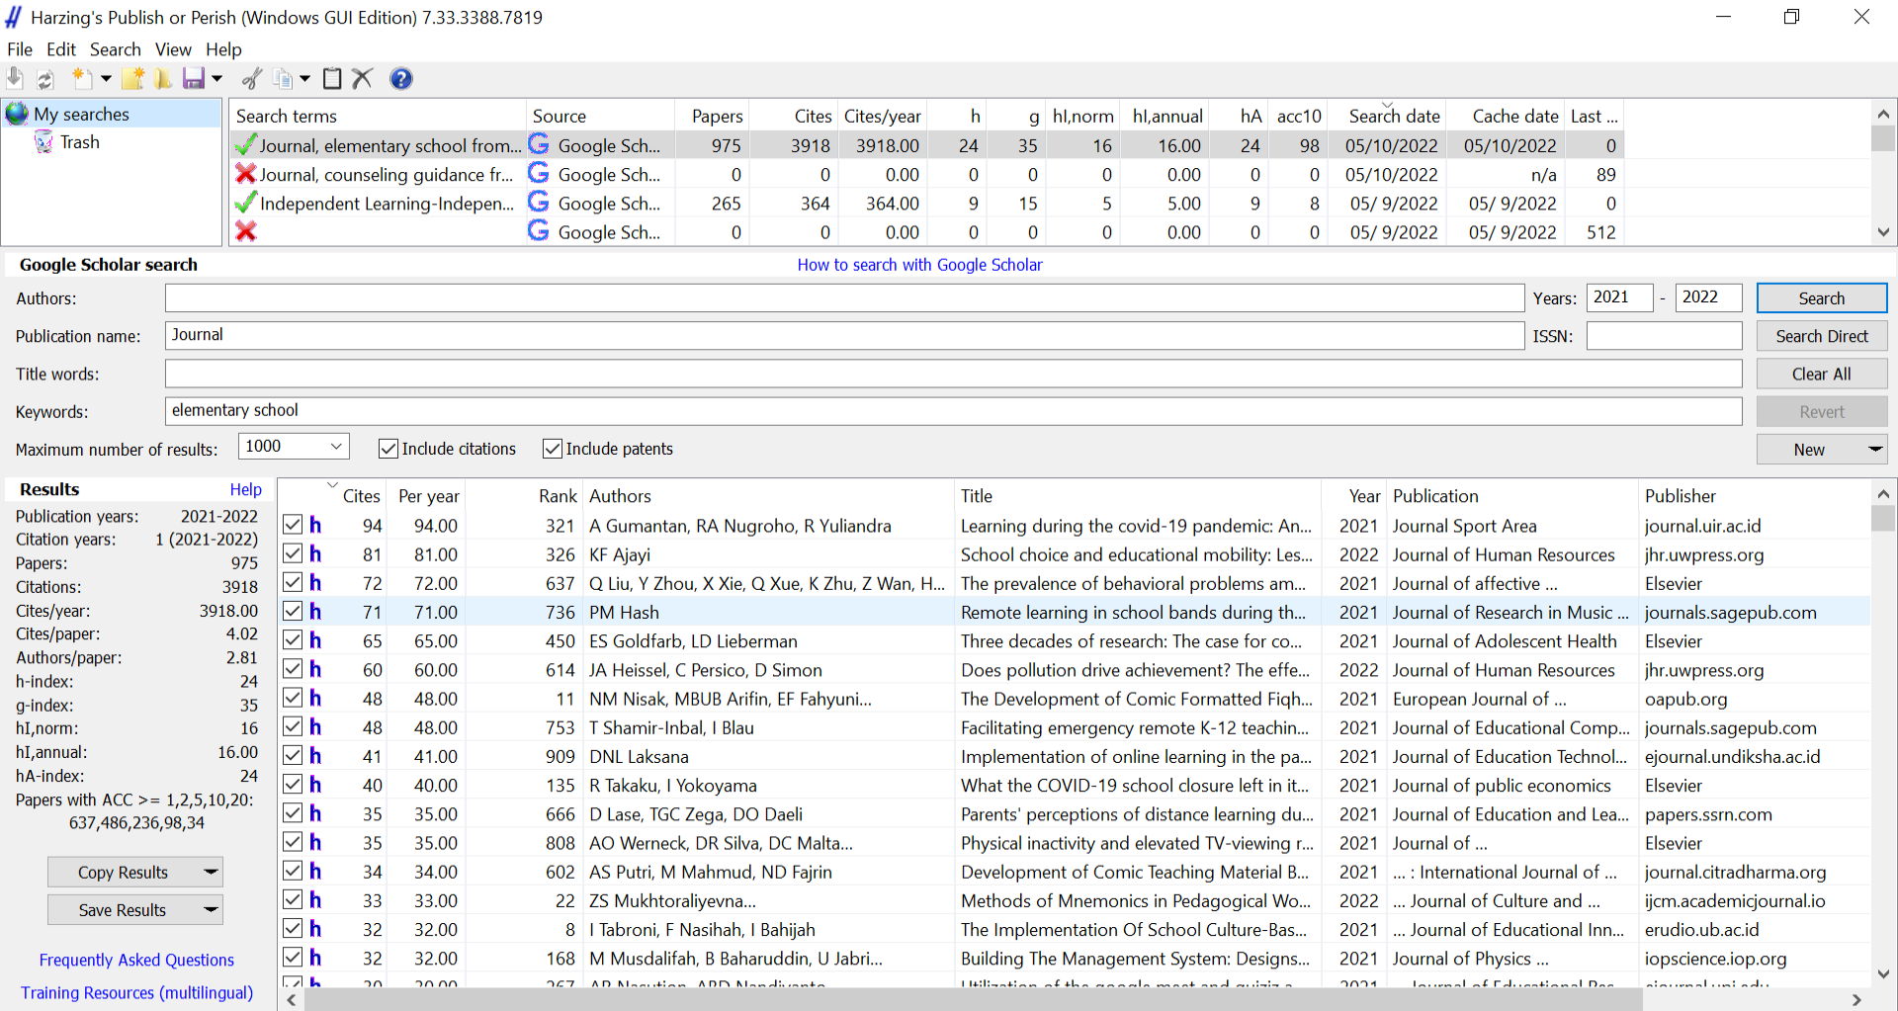

Figure 9. Publish or perish (windows GUI edition) about elementary school

The preliminary search results using the Publish or perish (windows GUI edition) 7.33.3388.7819 claim resulted in the term "elementary school” appendices, sorted into four terms designated appendices into publication name as journal and Google Scholar database. There were four keywords elementary school is 975 papers.They are **Reference date:** 2022-05-10 18:12:46 -0700

Publication years: 2021-2022, Citation years: 1 (2021-2022), Papers: 975

Citations: 3918, Citations/year: 3918.00 (acc1=637, acc2=486, acc5=236, acc10=98, acc20=34), Citations/paper: 4.02, Authors/paper: 2.81/3.0/3 (mean/median/mode), Age-weighted citation rate: 3912.00 (sqrt=62.55), 1750.85/author, Hirsch h-index: 24 (a=6.80, m=24.00, 1038 cites=26.5% coverage), Egghe g-index: 35 (g/h=1.46, 1275 cites=32.5% coverage), PoP hI,norm: 16, PoP hI,annual: 16.00, Fassin hA-index: 24

These are the papers most frequently cited by the graph's papers "a corpus-based study on the technology on the technical vocabulary of "counseling guidance ."It is usually indicated that they are seminal works in the subject, and it is a good idea to familiarize yourself with them (Swan et al., 2008). Picking a prior work will bring up all graph papers that reference it, and selecting a graph paper will bring up all prior work that has been referenced.

|  |  |  |  |  |
| --- | --- | --- | --- | --- |
| Title | Last Author | Year | Citations | Link or Journal |
| Developing a web-based application for school counseling and guidance during the COVID-19 Pandemic | L Oktaviani, Y Fernando, R Romadhoni | (2021) | cited by 20 (20.00 per year) | <https://ejournal.umm.ac.id/index.php/jcse/article/view/17630> |
| The development of group healing storytelling model in multicultural counseling services in Indonesian schools: Examination of disciplinary cases | M Fatchurahman, MA Setiawan | (2021) | cited 16 (16.00 per year) | <https://www.edscience.ru/jour/article/view/2106?locale=en_US> |
| Transition to telephone genetic counseling services during the COVID‐19 Pandemic | KM Shannon, MM Emmet, LH Rodgers | (2021) | cited by 16 (16.00 per year) | <https://doi.org/10.1002/jgc4.1365> |
| Evaluation of distance education: The sample of guidance and counseling students (Example of Aksaray University) | S Karagöz | (2021) | cited by 13 (13.00 per year) | The Universal Academic Research Journal  dergipark.org.t |
| Teacher Guidance and Counseling with Al-Islam and Kemuhammadiyahan in Ajatappareng Region: Learning Styles and Models of Islamic Education | E Elihami, A Agung | (2021) | cited by 3 (3.00 per year) | <https://ummaspul.e-journal.id/Edupsycouns/article/view/2307> |
| Conceptual Development of Online Psychological Assessment Training Design for Guidance and Counseling Teachers on the Academic Life of High School Students | N Hidayah, L Fauzan, F Wahyuni | (2022) | cited by 1 (1.00 per year) | ebscohost.com.   International Journal of Interactive Mobile Technologies |
| Youth and Children's Orchestras: Analysis of the Educational Experience and Some Reflections from the Field of Lifelong Guidance and Counseling | V Valenzuela, G Aisenson, ME Duarte | (2022) | cited by 1 (1.00 per year) | <https://link.springer.com/article/10.1007/s10775-022-09526-2> |
| The Role of Guidance and Counseling Services in Individual Counseling During The Covid-19 Pandemic | Daily Puji Astuti | (2021) | cited by 6 (6.00 per year) | <http://ejurnal.mercubuana-yogya.ac.id/index.php/IJAGC/article/view/1592> |

Figure 10. a corpus-based study of “counseling guidance” in 2021-2022

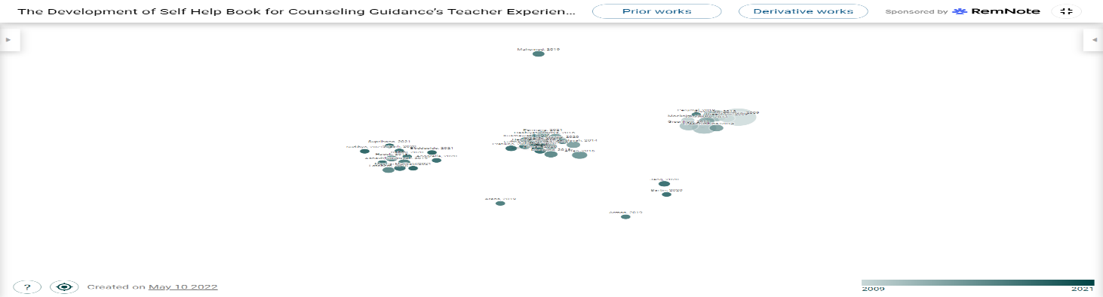

Figure 11. Prior Works about “counseling guidance."

The research outcomes remain presented by writing the processed data of publications in authors in Prior Works about “counseling guidance."

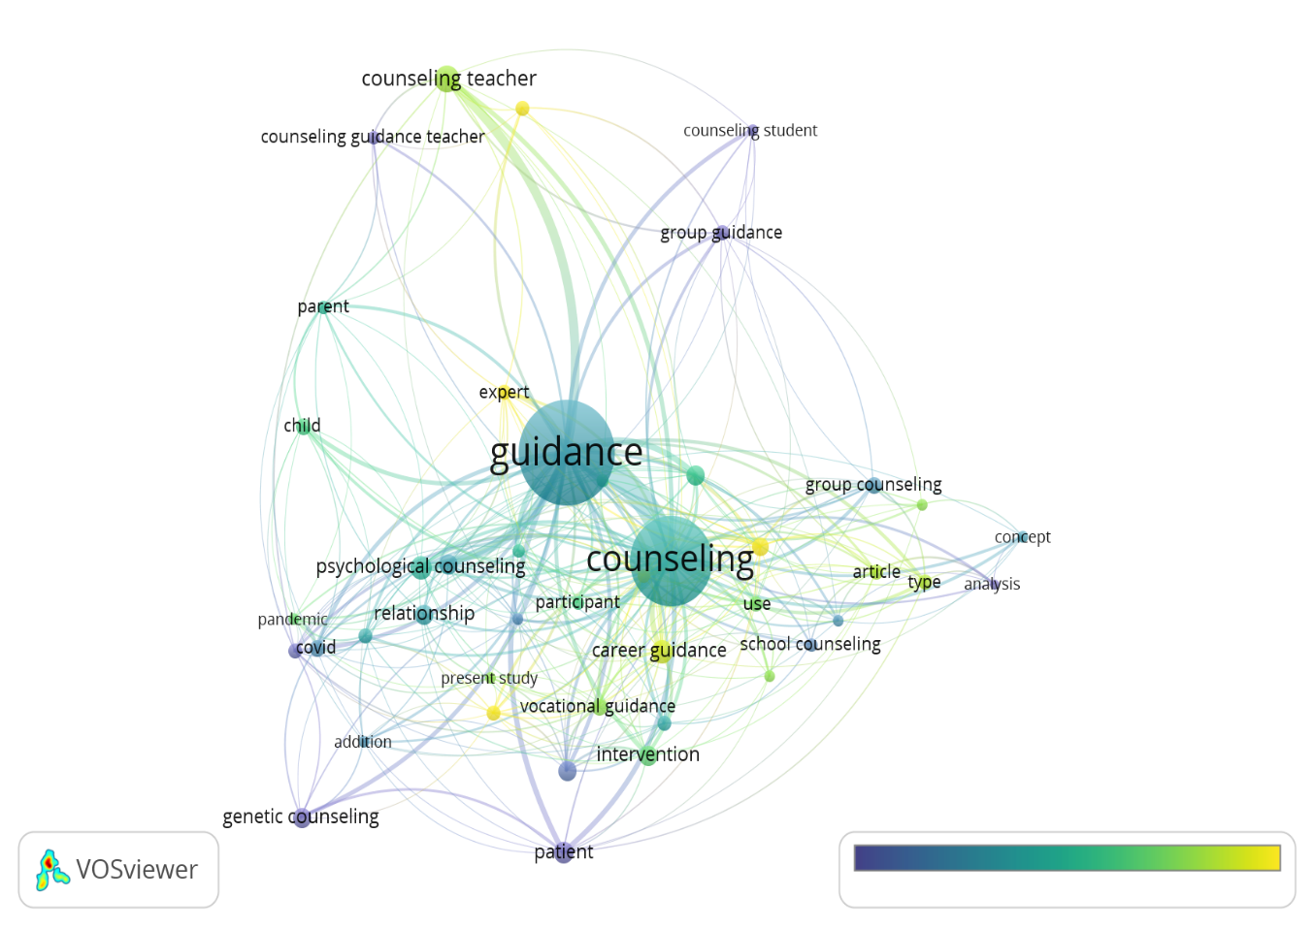

Figure 12. Network Visualization about “counseling guidance."

The search results using the VOSviewer application yielded 975 bibliographies, which were sorted into 150 selected bibliographies. There were 270 articles in the bibliography that were not selected because they did not meet the criteria set by the researcher. Figure 44 items from three clusters of search results through the VOSviewer application about counseling guidance. The first is career counseling, career guidance, counseling program, Counseling, individual, intervention, participant, the present study, relationship, researcher, school counseling, vocational guidance, and year. The second cluster is adolescent analysis, anticipatory guidance, article, effectiveness, group, and group counseling. The three-cluster addition covid field, genetic Counseling, impact, Pandemic, patient, person, and Psychological Counseling. The fourth cluster is child counseling guidance teachers, experts, group guidance, guidance teacher, and parent. The fifth is counseling students.

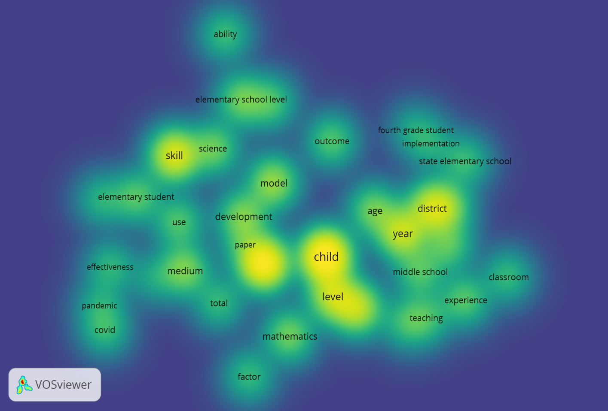

Figure 13. Density Visualization of elementary school

The search results using the VOSviewer application yielded 975 bibliographies, which were sorted into 230 selected bibliographies. There were 227 articles in the bibliography that were not selected because they did not meet the criteria set by the researcher. Figure 37 items from three clusters of search results through the VOSviewer application about elementary school. The first cluster is age, child, classroom, experience, high school, middle school, quality, teaching, and year. The second cluster is an ability, elementary school level, elementary student, order, paper, science, skill, and type. The three-cluster are district, fourth-grade student, implementation, model, and outcome. The fourth cluster is abstract, covid, development, effectiveness, medium, and use. The fifth cluster is elementary school child, factors, mathematics, and total.

Acknowledgment

We thank the professionals for their substantial contributions to the instrument's programming development and design. We also want to thank everyone who helped make the study a success.

Conflicts of Interest

The authors declare that there is no conflict of interest.

**Conclusion**

Religious character, discipline, and independence are all grown through school. The development of habits, the example provided by the principal and student supervisors, and the development of student motivation are all used to shape students' character through bibliometric studies from 2012 to 2022, an innovation in the role of religious teachers in counseling guidance in elementary schools. The bibliographic review taken was analyzed using the VOS viewer. The most prolific authors, journals, keywords, and citation references were all investigated. In 2021-2022 the relative growth rate and time required to double were calculated. The innovation of the role of religious teachers in counseling guidance in elementary schools is an innovation of the role of religious teachers as an example of associative social interaction, which requires cooperation in developing the character of students in elementary schools. . Based on the Al-Quran and As-Sunnah, Islam directs and guides humans to the path that is pleasing to Him by forming a personality with good morals. As the Messenger of Allah (SAW) said: "Indeed, I was sent to the perfect noble character. God sent the Prophet to guide and direct humans toward true goodness and as a counselor figure capable of solving various problems related to the human soul so that humans avoid all negative traits. Therefore, humans are expected to give each other guidance following their capacity and provide Counseling to remain patient and trusting in facing the real journey of life.

References

Agarwal, S., and D. Roth. 2002. “Learning a Sparse Representation for Object Detection.” doi: 10.1007/3-540-47979-1_8.

Akyol, Zehra, and D. Garrison. 2008. “The Development of a Community of Inquiry over Time in an Online Course: Understanding the Progression and Integration of Social, Cognitive and Teaching Presence.” *Journal of Asynchronous Learning Networks* 12:3–22. DOI: 10.24059/OLJ.V12I3.66.

Akyol, Zehra, D. Garrison, and M. Ozden. 2009. “Development of a Community of Inquiry in Online and Blended Learning Contexts.” *Procedia - Social and Behavioral Sciences* 1:1834–38. DOI: 10.1016/J.SBSPRO.2009.01.324.

Akyol, Zehra, D. Garrison, and M. Ozden. 2009. “Online and Blended Communities of Inquiry: Exploring the Developmental and Perceptional Differences.” *The International Review of Research in Open and Distributed Learning* 10:65–83. DOI: 10.19173/IRRODL.V10I6.765.

Alavi, S. M., and M. Taghizadeh. 2013. “Cognitive Presence in A Virtual Learning Community: An EFL Case.” *International Journal of E-Learning and Distance Education* 27:1.

Annand, David. 2011. “Social Presence within the Community of Inquiry Framework.” *The International Review of Research in Open and Distributed Learning* 12:40–56. DOI: 10.19173/IRRODL.V12I5.924.

Arbaugh, J., A. Bangert, and M. Cleveland-Innes. 2010. “Subject Matter Effects and the Community of Inquiry (CoI) Framework: An Exploratory Study.” *Internet High. Educ.* 13:37–44. doi: 10.1016/J.IHEDUC.2009.10.006.

Arbaugh, J., and Raquel Benbunan-Finch. 2006. “An Investigation of Epistemological and Social Dimensions of Teaching in Online Learning Environments.” *Academy of Management Learning and Education* 5:435–47. DOI: 10.5465/AMLE.2006.23473204.

Arbaugh, J., and B. Rau. 2007. “A Study of Disciplinary, Structural, and Behavioral Effects on Course Outcomes in Online MBA Courses.” *Decision Sciences Journal of Innovative Education* 5:65–95. DOI: 10.1111/J.1540-4609.2007.00128.X.

Diaz, S., Karen Swan, P. Ice, and L. Kupczynski. 2010. “Student Ratings of the Importance of Survey Items, Multiplicative Factor Analysis, and the Validity of the Community of Inquiry Survey.” *Internet High. Educ.* 13:22–30. doi: 10.1016/J.IHEDUC.2009.11.004.

Duggan, S. 1996. “Education, Teacher Training and Prospects for Economic Recovery in Cambodia.” doi: 10.1080/03050069628768.

Fergus, R., P. Perona, and Andrew Zisserman. 2003. “Object Class Recognition by Unsupervised Scale-Invariant Learning.” *2003 IEEE Computer Society Conference on Computer Vision and Pattern Recognition, 2003. Proceedings.* 2:II–II. DOI: 10.1109/CVPR.2003.1211479.

Garrison, D., T. Anderson, and R. Garrison. 2003. “E-Learning in the 21st Century: A Framework for Research and Practice.” doi: 10.4324/9780203166093.

Holmes, E., R. O’Connor, V. Perry, I. Tracey, S. Wessely, L. Arseneault, C. Ballard, H. Christensen, Roxane Cohen Silver, I. Everall, T. Ford, A. John, T. Kabir, Kate King, I. Madan, S. Michie, Andrew K. Przybylski, R. Shafran, A. Sweeney, C. Worthman, L. Yardley, K. Cowan, C. Cope, M. Hotopf, and E. Bullmore. 2020. “Multidisciplinary Research Priorities for the COVID-19 Pandemic: A Call for Action for Mental Health Science.” doi: 10.1016/S2215-0366(20)30168-1.

Kadiyono, A., Rezki Ashriyana Sulistiobudi, I. Haris, Mohd Hanif Abdul Wahab, I. Ramdani, A. Purwanto, A. Mufid, Muhammad Rikza Muqtada, M. Gufron, Mohamad Nuryansah, Lina Aris Ficayuma, M. Fahlevi, and Susila Sumartiningsih. 2020. “Develop Leadership Style Model for Indonesian Teachers Performance in Education 4.0 Era.” *Systematic Reviews in Pharmacy* 11:363–73.

Kumar, Swapna, K. Dawson, E. Black, Cathy Cavanaugh, and Christopher D. Sessums. 2011. “Applying the Community of Inquiry Framework to an Online Professional Practice Doctoral Program.” *The International Review of Research in Open and Distributed Learning* 12:126–42. DOI: 10.19173/IRRODL.V12I6.978.

Lowe, D. 1999. “Object Recognition from Local Scale-Invariant Features.” *Proceedings of the Seventh IEEE International Conference on Computer Vision* 2:1150–57 vol.2. DOI: 10.1109/ICCV.1999.790410.

Osuna, E., R. Freund, and F. Girosi. 1997. “Training Support Vector Machines: An Application to Face Detection.” *Proceedings of IEEE Computer Society Conference on Computer Vision and Pattern Recognition* 130–36. DOI: 10.1109/CVPR.1997.609310.

Rourke, L., T. Anderson, D. Garrison, and W. Archer. 2007. “Methodological Issues in the Content Analysis of Computer Conference Transcripts.”

Rowley, H., S. Baluja, and T. Kanade. 1998. “Neural Network-Based Face Detection.” *IEEE Trans. Pattern Anal. Mach. Intell.* 20:23–38. doi: 10.1109/34.655647.

Supriadi, Oding, Zulkifli Musthan, Sa’odah, Rizki Nurjehan, Y. Haryanti, M. R. Marwal, A. Purwanto, A. Mufid, Rohmad Adi Yulianto, Moh Farhan, A. Fitri, M. Fahlevi, and Susila Sumartiningsih. 2020. “Did Transformational, Transactional Leadership Style and Organizational Learning Influence Innovation Capabilities of School Teachers during Covid-19 Pandemic?” *Systematic Reviews in Pharmacy* 11:299–311. DOI: 10.31838/SRP.2020.9.47.

Vaillant, Régis, C. Monrocq, and Y. L. Cun. 1994. “Original Approach for the Localisation of Objects in Images.” doi: 10.1049/IP-VIS:19941301.

Viola, Paul A., and Michael J. Jones. 2001. “Rapid Object Detection Using a Boosted Cascade of Simple Features.” *Proceedings of the 2001 IEEE Computer Society Conference on Computer Vision and Pattern Recognition. CVPR 2001* 1:I–I. DOI: 10.1109/CVPR.2001.990517.

Weber, Markus, M. Welling, and P. Perona. 2000. “Unsupervised Learning of Models for Recognition.” doi: 10.1007/3-540-45054-8_2